Cabrini Help

Email Korilyn at least 1-2 weeks before starting and tell her you are a new LSU anesthesia student and need login info: korilyn.sicuro@christushealth.org

After you email Korilyn, she will send you login instructions. You will have to make a new password; do this at home before going to the hospital. When you get to the hospital you will use this new login and password to get Pyxis access. If you want to make Keith super happy, do this before he gets there. There is a Pyxis in the core located off the locker rooms that you login to and create a fingerprint.
They have surgical green scrubs available in the locker room, or you can wear yours as long as they are the correct color.

Directions once you get to the hospital:
- Park in the parking garage on the 3rd floor.
- There are 2 skywalks (Women and Children’s Hospital side and main hospital side); skybridge is on the second floor so you will walk down a level.
- Once you come out of the sky bridge turn left towards the scary nun statue.
- If you came through the women and children’s sky bridge this is your view: 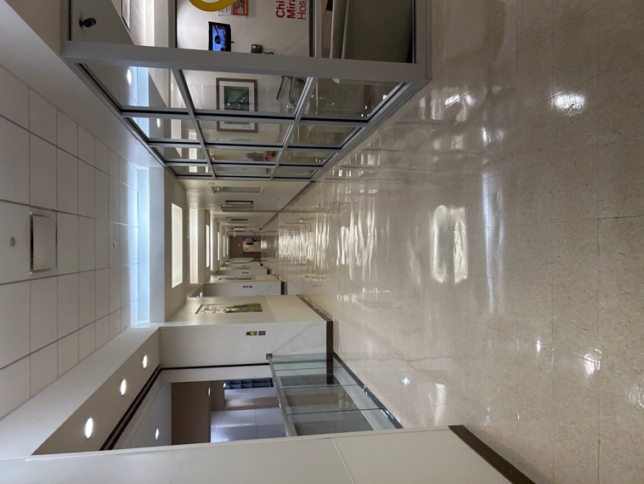
- If you came through the main bridge, this is your view: 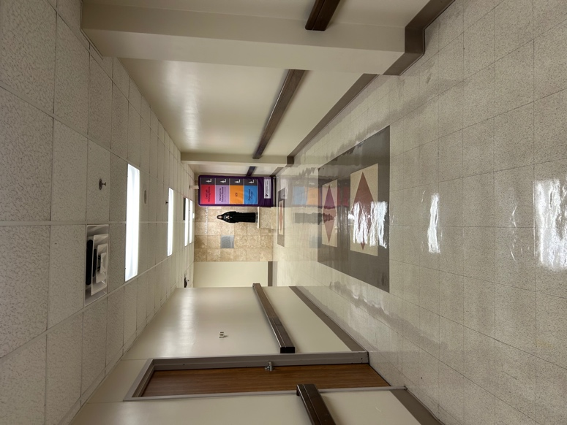
- Continue past the statue; when you get to this point, turn right 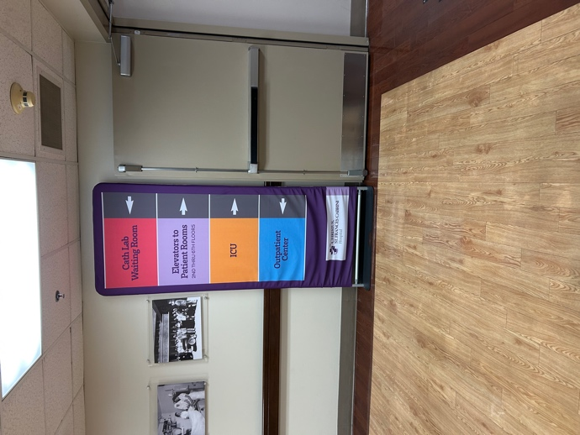
- Approximately 15 feet there will be a door on the left and a staircase on the right; since you don’t have a badge yet, take the stairs down to the first floor. 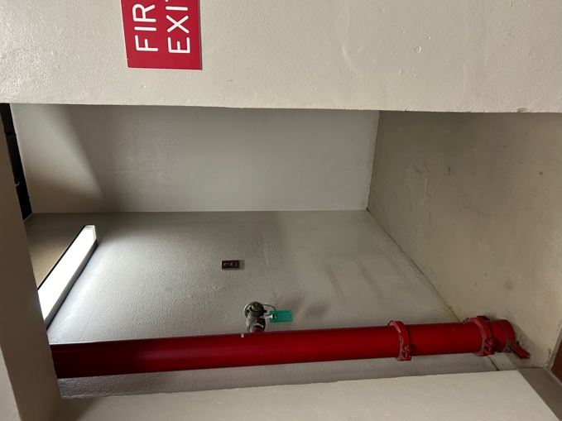
  - If you somehow can make it through the door, it will put you in cath lab; stay straight and at the end of the hall is an elevator on the left. Take the elevator down to the first floor. Come off the elevator and to the right is the board and main desk.
- Come out of the staircase and turn left toward the cafeteria. When you get to the first hallway turn left. You will have to go through some automated doors, but stay straight. 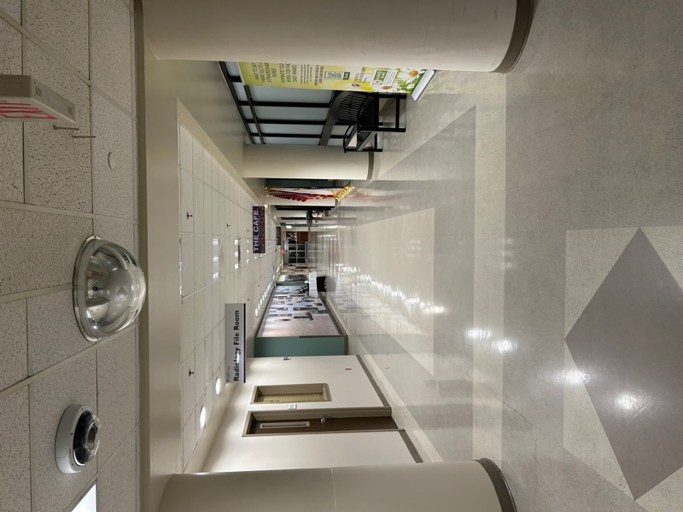
- You will arrive outside the OR doors. You need a badge to get in here, but usually there are people in there so you can knock or wait for someone to answer the door 