Pyxis Training for Anesthesia / Surgical Department
To be able to have access to medication in the OR room you will need to complete online training of the Anesthesia Pyxis machine. Please follow the direction below and once training is complete email a copy of course certificate. The attached PDF has visuals to help with the process if instructions are not clear.
Step 1:
Clinic the following link:
https://bd.com/learningcompass
Clinic Sign Up
Under Select an Application to register for: select
Learning Compass
Put in personal Email address, confirm address
Which BD brand would you like available for future training? Select
Dispensing Products
Infusion products
User type: select
Customer
Click Next:
Step 2:
Enter:
First and Last name, correct staff position, you phone number, and facility zip (71459)
Click next:
Step 3:
Under facility select:
Bayne Jones Army Community Hospital
Clinic Next:
Step 4:
Create a password: 8 characters, 1 upper, 1 lower, 1 number
Click Terms and Condition box
Select next
You will then receive a confirmation email once you for account approval (check spam/junk folder). It may take up to 24-72 hours depending when you complete the request.
Once you receive the email open the web address in the email which will confirm the email address.
Then you can log in with your email and password and complete the training called “DOD Anesthesia ES System Training”
Email Certificate of completed training.

** at the top of the website in the search window , type DoD
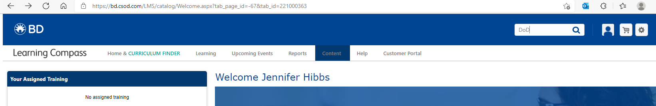
** a global search of DoD learning curriculums will show up.
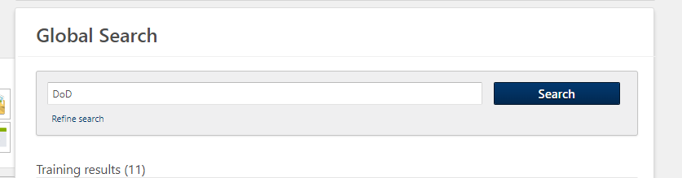
** Scroll down to see the DoD Anesthesia Provider – Anesthesia ES System
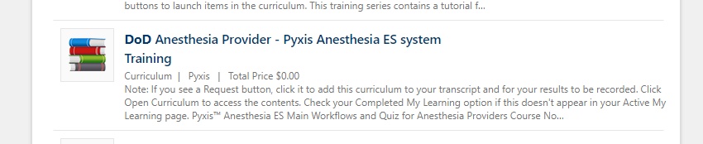
** Click Open curriculum & Launch
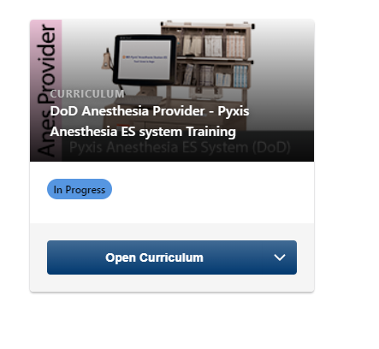
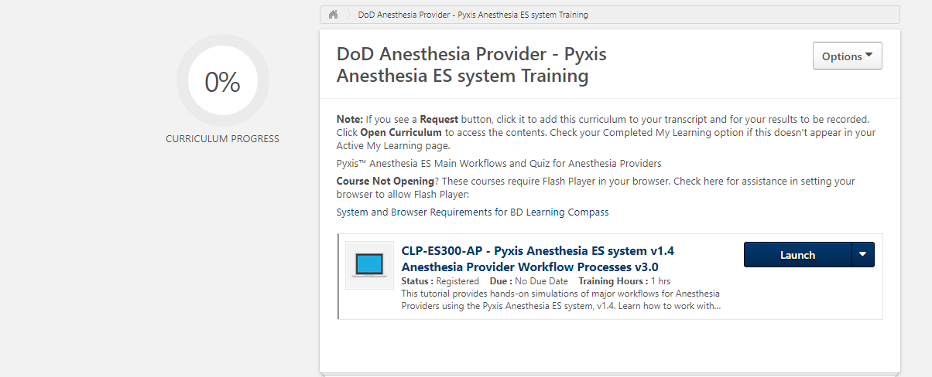

** Once completed, under “OPTIONS” view completion, download certificate, and email to NCO/NCOIC incharge of department so they can forward to Pharmacy Department personnel with access request email, and /or MFR that includes all of the requirements seen below.
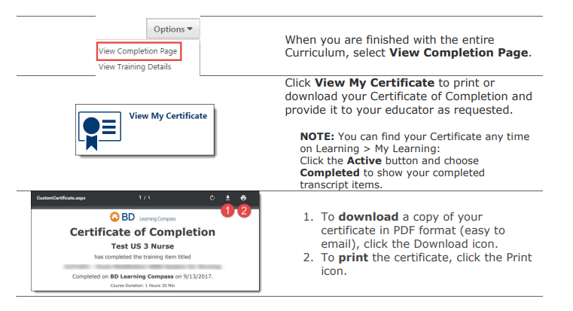

Email requests should include all of the following: see below.
___________________________________________________________________________________
A request for new user access for Pyxis was made for you or on your behalf.
For both creation of new user accounts and requests for user access updates, please completely fill out the requested information. It will ensure that user access is up to date and accurate for the user. Please include all of the following information in your request.
-Full name of user-
-Email address of user
-Department(S) where user needs access to Pyxis :
-Job Title
-Describe specialty (scope of practice) (examples are LPN, BSN, Medical Technician, MD, Provider with LIP privileges, CRNA, Pharmacy Technician, Pharmacist, Student user)
-If user access is for a specific amount of time, Known Expiration Date of User access, Date___________ for Department ______________
-If Yes, Provide Dates of required access for each specific Department and Pyxis location
____________________________________________________________________________________

