Ochsner Foundation Medical Center
1514 Jefferson Highway
New Orleans, LA 70122
504-842-4000

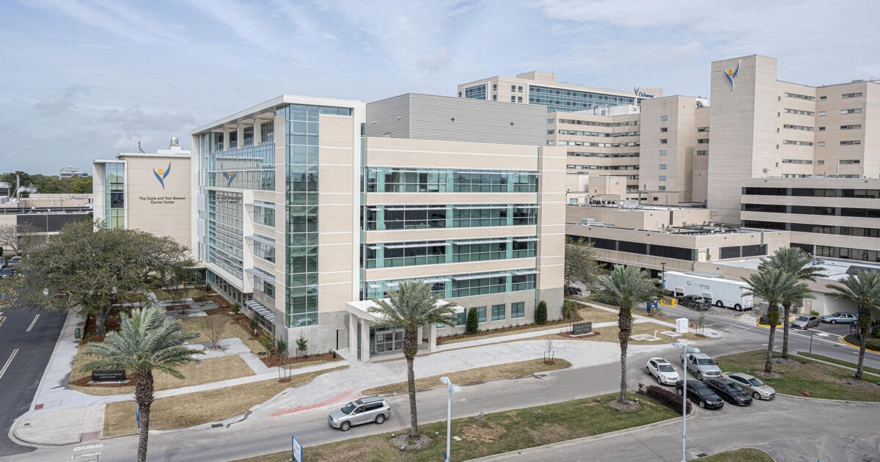

Clinical Education Lead:
Caitlin Burmaster DNP, CRNA
504-354-3345 work hours
caitlin.burmaster@ochsner.org

Student Liaison:
Rebecca LeBlanc DNP, CRNA
504-354-3375 work hours
Rebecca.leblanc@ochsner.org

CRNA Supervisors: Robin Bundick and Megan Kushner
Anesthesia Office: 504-842-5344

Required Forms: Please complete and upload all forms to InPlace

If you have any question, please contact:
Undergraduate Medical Education
clinicaleducation@ochsner.org
504-842-3267

Orientation to Clinical Site

- You will be given an orientation on your first day. If you are scheduled for evening shifts, please come the first day for 6:15am for orientation. We will meet you for 6:15am at the main entrance (Jefferson Hwy) by the inside sitting area with the fish statue. You will receive a security badge for department access and offered a locker. The security badge must be turned in on your last clinical rotation day…please do not lose this badge.
- Students should park in the Coolidge Lot which is across Jeff Hwy from the hospital. You can walk across the street or wait for the shuttle which runs every 15 minutes. Please allow at least 15 minutes travel time from your parked car to the hospital regardless if you walking or taking the shuttle.
- There are over 28 ORs which are located on the 2nd floor, 6 outpatient surgery suites on the 1st floor and various outside areas. On a typical day we can staff up to 50 anesthesia locations.
- You should arrive at the hospital no later than 6:00am for your daily clinical shift. SRNAs are expected to wear Ochsner scrubs, which will be provided. You should allow for enough time to change into them. Required equipment: stethoscope, school ID badge and nerve stimulators.
- If you are unable to attend clinical for any reason you must notify your clinical coordinator via text, as well as call Anesthesia (504-842-5344) at least 2 hours prior to your shift.

Experiences Available to the SRNA

- The SRNA is afforded a multitude of cases encompassing all ages and levels of acuity.
- Additionally, the SRNA has the option of taking transplant call with a CRNA. This option, however, is first offered to the senior SRNA.
- Wednesday mornings are for the Patient Safety Conference, you are expected to attend. Your room should be set up prior to attending the meeting. If your room requires a lengthy set up and you are unable to attend, you will be excused. The anesthesia residents will be presenting and therefore, you will not be required to do a presentation.

Patient Assignments

- Assignments are generally made the day before surgery, around 3pm. The SRNA may request a particular case, however the clinical coordinator and board runner will make the final decision.
- Ochsner has protocol anesthesia care plans for complex cases which the student must review the night before. The CRNA or board runner can print them for the student from the hospital database.
- Pre-ops are typical performed by the anesthesiologist, but the SRNA is encouraged to interview their patient as well.
- Patients will occasionally request a particular CRNA or Anesthesiologist to perform the anesthesia. As such, the SRNA may not be allowed in the room. This is patient’s right and the SRNA should respectfully comply.
- Make a list of the types of cases you need and discuss with the clinical coordinator. Your requests will try to be accommodated.

Daily Clinical Routines
0600-1500
- Set up room and prepare all needed medications for your patient.
- Your preceptor signs out narcotics
- Proceed to pre-op holding to review the chart and interview your patient.
- Ensure at this time that all of the necessary paperwork is completed and that all consents are signed. Anesthesia consents are done electronically
- Prior to proceeding to the OR, you must first confirm that the surgeon has arrived and is physically in the hospital. Check with the circulator for this information.
- Surgery begins at 0700.
Evening Shift
- CRNAs are given their evening room assignments at 2:25pm in order to be in the room to get report for 2:30pm relief. Please be sure to review the screens of cases going on and discuss desired rooms with the board runner.

REMEMBER:
Absolutely NO medications are to be administered prior to:
- Ensuring that the patient has signed all applicable paperwork.
- You have discussed your anesthetic plan with you preceptor.
- The circulating nurse has completed their patient interview
- Patient transport to the OR and to PACU or ICU is the responsibility of the anesthetist.
- ICU patients are to be transported on ICU provided transport monitor.
- You are allotted a thirty minutes lunch at the discretion of your preceptor.
- The hospital cafeteria is located on the first floor for those who choose this option, however the line is usually long and takes a while to get your lunch.

