**Welcome to**

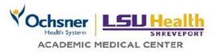

**Student Information Packet**

Please read the following information to help orient you to Ochsner LSU Health Shreveport Monroe Medical Center. Once you have read the material, sign the Student Information Acknowledgement section of the *Required Signature Page for Clinical Rotations*.

Students can park in either of the 2 big parking lots left or right of the front door. Please do not park on the front 2 rows. Do not park in the Emergency Room Parking lot.

**Staff Development/Standards**

**Clinical Educator**

Steve Jordan, MSN, RN, VA-BC

*Ochsner LSU Health is a smoke free environment and tobacco free campus!*

**CONTENTS**

|  |  |
| --- | --- |
| **TOPIC** | **PAGE** |
| **Mission** | **3** |
| **Patient Rights and Responsibilities** | **3** |
| **Badges** | **3** |
| **Advance Directives** | **4** |
| **Ethical Issues** | **4** |
| **Abuse and Neglect** | **4** |
| **Safety** | **5** |
| Medical Gases | **5** |
| Security | **5** |
| Electrical | **5** |
| Radiation | **5** |
| Safety Data Sheets | **6** |
| Systems Failure | **6** |
| **On-the-Job Injury** | **6** |
| **Hospital Emergency Plan for Disasters/Emergency Codes** | **7** |
| Code Blue-Medical Emergency | **7** |
| Code Silver-Weapon | **7** |
| Code Red-Fire/Fire Safety | **8,9** |
| Code Gray-Severe Weather | **10** |
| Code Pink-Infant/Child Abduction | **10** |
| Code Black-Bomb | **10** |
| Code Green-Violent Patient | **10** |
| Code White-Security Alert/Hostage | **11** |
| Code Yellow-Disaster/Mass Casualty | **11** |
| Code Orange-Hazardous Material | **11** |
| **Infection Control** | **12** |
| **OSHA Standard Prohibits** | **12** |
| Handwashing | **12** |
| Isolation Guidelines | **13** |
| Multi-Drug Resistant Organisms | **14** |
| **Sharps** | **14** |
| **Medical Waste** | **15** |
| **Age Specific Care** | **15** |
| **Falls** | **15** |
| **End of Life Care** | **15** |
| **Newborn Safe Haven Law** | **16** |
| **“Do Not Use” Abbreviations** | **16** |
| **Student Information Packet Acknowledgement Form** | **17** |

**Mission of Ochsner LSU Health**

The primary mission of Ochsner LSU Health is to teach, heal and discover in order to advance the well-being of the community. Ochsner LSU Health is committed to:

* Providing state-of-the-art clinical care.
* Educating physicians, basic scientists, residents, fellows, nurses and allied health care professionals preparing students for careers in healthcare, teaching or research.
* Achieving recognition for basic science and clinical research.
* Supporting the region.

**Patient Rights and Responsibilities**

Patient Rights apply to all persons that come to this facility for care. Patient Rights include:

* Access to Care
* Respect and Dignity
* Privacy and Confidentiality
* Safety and Security

Some methods to address safety and security are the Ochsner LSU Health Police patrols, electronic access cards on exterior entrances, video monitoring and the use of employee identification badges.

* The right to know the identity and professional status of individuals providing service.
* Complete and current information concerning diagnosis, treatment, pain management.
* Communication
* The right to reasonably informed participation in decisions involving health care.
* The patient, at his/her own request and expense, has the right to consult with a specialist.
* Transfer and Continuity of Care

Patients must be given an explanation of the need for a transfer and any alternatives. Patients will be informed of any continuing healthcare requirements following discharge.

* Information of hospital rules and regulations applicable to his/her conduct as a patient.
* The patient has the right to file a complaint and to information regarding the complaint process.

Patient Responsibilities are patient actions needed so healthcare providers can provide appropriate care. Patients have the responsibility for:

* Providing accurate and complete information about matters relating to their health;
* Following the treatment plan;
* Ensuring that their bills are paid as promptly as possible;
* Being considerate of the rights of other patients and hospital personnel; and
* Seeking information and asking questions if they do not understand.

The Patient Handbook, given to all inpatients when they are admitted to the hospital, contains information on Patient Rights and Responsibilities.

**Badges**

**Students under facility contracts, i.e., Nursing programs, Radiology Technologist, etc., shall wear identification badges issued by their sponsoring institution while doing rotations.**

**Advance Directives**

Advance Directives are defined as living wills, healthcare power of attorney, “Five Wishes” or other instructions of a patient about their medical and psychiatric care. These explain the patient’s instructions about medical treatment if they are unable to make decisions for themselves.

**Ethical Issues**

An ethical issue is identified whenever a healthcare worker or patient questions the moral quality of a course of action. The Medical Director may appoint a committee to discuss the specific situation.

**Abuse and Neglect**

**Abuse -** is defined as the “infliction of physical or mental injury on an individual by other parties, including but not limited to such means as sexual abuse, exploitation, or extortion of funds or other things of value, to such an extent that his/her health, self-determination, or emotional well-being is endangered.” (R.S. 14:403.2).

**Neglect -** is defined as the refusal or failure of a parent or caretaker to supply the individual with necessary food, clothing, shelter, care, treatment, or counseling for any injury, illness, or condition of the individual, as a result of which the individual’s physical, mental or emotional health is substantially threatened or impaired.

**Domestic Violence -** is “abuse committed against an adult or a fully emancipated minor who is a spouse, former spouse, co-habitant, former co-habitant or a person with whom the suspect has had a dating or engagement relationship.”

**Internal Abuse and Neglect -** is defined as abuse or neglect that occurs while the patient is under the hospital’s care.

|  |  |
| --- | --- |
| Type of Abuse | Some signs of Abuse |
| Physical | Unusual or unexplained bruising, fractures, burns, head injuries, retinal bleeding in infants |
| Rape/Sexual Molestation | Trauma to genitalia, repeated urinary tract infections, pregnancy or sexually transmitted diseases in infants and children |
| Emotion or Psychological Abuse | Withdrawn or aggressive behavior, inappropriate parent/child interaction, depression, conduct disorder |
| Neglect | Lack of personal hygiene and/or appropriate clothing, lack of medical care, lack of immunizations, failure to thrive |
| Domestic Abuse | Fractures, burns, repeated injuries, ingestions, alleged self-injury, delays in getting care |

**Reporting Abuse and Neglect:** A Licensed Healthcare Professional shall notify the appropriate authorities immediately and BRFHH Social Services (57075) of all cases of suspected abuse/neglect; next working day for reports that occur after hours.

**Safety**

**Medical Gases**

**Where are the medical gases – such as Oxygen (O2) – shut off valves located?**

They are located when you first enter the unit or by the nurse’s station. They have a plastic face which is easily removed and the label should refer to your area.

**Who can shut off medical gases?**

The nurse manager is in charge of all shutting off medical gases, until relieved by higher authority.

**Security**

Security officers are on duty at all times and may be called to assist in any situation where the staff feels insecure or at risk.

Officers may be contacted by dialing **7-5555.**

**Electrical Safety**

* All plugs are 3 pronged.
* Always unplug by pulling on the plug, NOT the power cord.
* Be alert for damaged cords and DO NOT use them.
* Don’t put anything wet on electrical equipment.
* Keep electrical devices away from wet floors.
* Malfunctioning devices are removed from service. If the device is patient care equipment – notify the charge nurse who will complete a variance report. A red defective tag is placed on the equipment.
* Any electrical appliance brought in by a patient must be checked by the Biomedical Department prior to patient use.



**How can you tell if a piece of medical equipment is safe to use?**

Biomed has a schedule for inspecting all patient-care equipment. The date on the item’s safety inspection should be current.

rent.



**Radiation Safety**

3 Cardinal Principles of Radiation Safety

* Time
* Distance
* Shielding

If you are pregnant and working in an area where radiation is being used, notify your supervisor immediately

**Safety Data Sheets**

Right to Know: You have a need and a right to know the identities, hazards and protective measures for each chemical you are exposed to while working.

Hazard Communication: OSHA requires all employers with hazardous chemicals in their workplace to have labels and Safety Data Sheets (SDS) for their exposed workers and train employees to handle the chemicals appropriately.

Safety Data Sheets are found in the area where the chemical is used, in the Safety Office or in the manufacturer’s website.



**Systems Failure**

Examples of systems failures are electrical power outage, elevators out of service, elevators stopped between floors, no gases or leak of gases, water outage, no heating or air conditioning etc.

If you become aware of any of these problems or any others, immediately notify both the charge nurse/nurse manager and your instructor!

**On-The-Job Injury**

An on-the-job injury is any injury to you on Ochsner LSU Health property. Contact of blood or body fluids to broken skin or mucous membranes or percutaneous injury, such as cut or needle stick, is a reportable injury.

All students should contact their instructor for your school policy for any on-the-job injuries.

All on-the-job injuries require completion of a variance report by unit supervisor.

Notify the supervisor and your instructor as soon as possible.

**Report to Emergency Room located on first floor for any necessary immediate treatment. Any cost for treatment will be the responsibility of the student.**

**Hospital Emergency Plan for Disasters**

A disaster is any unplanned event that can cause death or serious injury to patients, staff or the public. A disaster may be internal/external, acts of terrorism and natural disasters.

If you hear a disaster page, stay in your work area and follow directions of the supervisor.

Below are helpful hints. For additional information, review the Safety Manual which is online.

**Emergency Codes**

**Code Blue Medical Emergency**



**Code Blue: Medical Emergency**

* Person found to have had a Cardiac and/or Respiratory arrest
* Dial **6-1123**, yell for assistance, start CPR is you have been taught

CODE Silver Weapon Crisis Alert



**Code Silver: Weapon Crisis Alert**

If you are in the Code Silver area:

* Evacuate if possible.
* Seek cover/protection and warn staff, students, visitors, and patients of the situation.
* Do not panic and stay alert.
* Go to a room that can be locked or barricaded.
* Turn off lights and silence communication devices.

If you ARE NOT in the Code Silver area:

* Upon hearing Code Silver, stay away from the area specified.
* Seek cover/protection and warn staff, students, visitors, and patients of the situation.
* Close all room doors and exit doors.
* Take cover behind locked doors, if possible

**Code Red Fire**



**Fire Safety**



**What is our code for a fire? CODE RED**

**What should you do if you discover a fire?**

Rescue:



Alarm

Confine

Extinguish

Rescue:

Remove patients, visitors, staff and yourself from the immediate area of the fire or smoke. The method of moving patients will depend on their condition.

Alarm

The following steps should occur simultaneously:

* Call out CODE RED and room number.
* Staff nearest the pull station activates the alarm – pull stations are located near exit stairs and at some nurse stations.
* Call University Police at 5-6165 and give them your name, exact location of the fire and type of fire (Example: Jane Doe, 2J-Room 37, mattress on fire).

Confine

Shut off any oxygen outlets in the room. Close all windows and doors in the fire area as you leave the room. This will contain the fire and smoke in the fire area and give you time to evacuate patients, if needed, in your wing to an area of safety.

Extinguish

Fight the fire only if it is a small, controllable fire. Otherwise, close the door and assist in evacuation of the area as directed by the supervisor in charge.

**How do you use a fire extinguisher?**

**PASS**

**P**ull the pin

**A**im the nozzle at the base of the fire

**S**queeze the handle

**S**weep the nozzle from side to side



**Always position yourself with an exit or means of escape at your back before you attempt to use an extinguisher to put out a fire.**

**How do you evacuate?**

General Instructions:

* Have all patients and visitors return to their rooms when possible.
* Close all doors leading into the corridor.
* Remove all moveable equipment from corridor.
* Do not use the elevators when the fire alarm sounds.
* Station one person at the telephone to relay instructions.
* Station someone at stairwell doors, smoke barrier doors, and exit doors to prevent movement of patients, visitors and staff in halls.

Evacuation Procedure:

* When possible, patients will be moved horizontally from the fire area through the fire/smoke doors to a safe area of refuge on the same floor.
* In a hospital, total evacuation or even partial vertical evacuation is not desirable except in the most extreme circumstances.
* The Shreveport Fire Dept., Hospital Administration, Nursing Administration, or House Supervisor will be responsible for initiating the evacuation order.

Order of Patient Evacuation:

1. Patients nearest the fire

2. Ambulatory patients

3. Helpless/non-ambulatory patients

**Where are the fire pull stations?**

They are located next to exit stairwells and at designated exits.

Locate the pull station in your area.

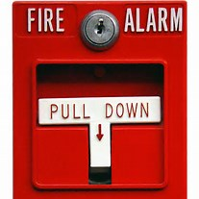

**Code Gray Severe Weather**



**Code Gray/Severe Weather:**

A **tornado** is sighted or in the immediate area of Ochsner LSU Health.

* Personnel supervise movement of all ambulatory patients and visitors to the hallway corridors away from glass.
* Put as many walls as possible between you and the outside.
* Stay off of the elevators – you could be trapped if power is lost.
* Place blankets, linens, mattresses on the floor to lie on.
* Move patient care equipment needed to care for patients to the corridor.
* Maintain appropriate space in corridor for personnel to move safely among patients.
* Close all doors.
* Personnel shall assist patients in lying flat or sitting down with head covered with blanket.
* Pull drapes and/or lower window shades to protect nonambulatory patients from flying glass. If possible, move these patients across the room as far as possible from the windows.

**Code Pink Infant/Child Abduction**



**Code Pink: Infant/Child Abduction**

* Look if public areas of your unit, including corridors, stairwells, bathrooms, etc.
* Be alert for anyone acting suspicious, carrying an infant or small child or carrying a large bag which could conceal a child.
* If seen, immediately notify UPD (5-6165) of the description of the individual and the direction they are headed.

**Code Black Bomb**

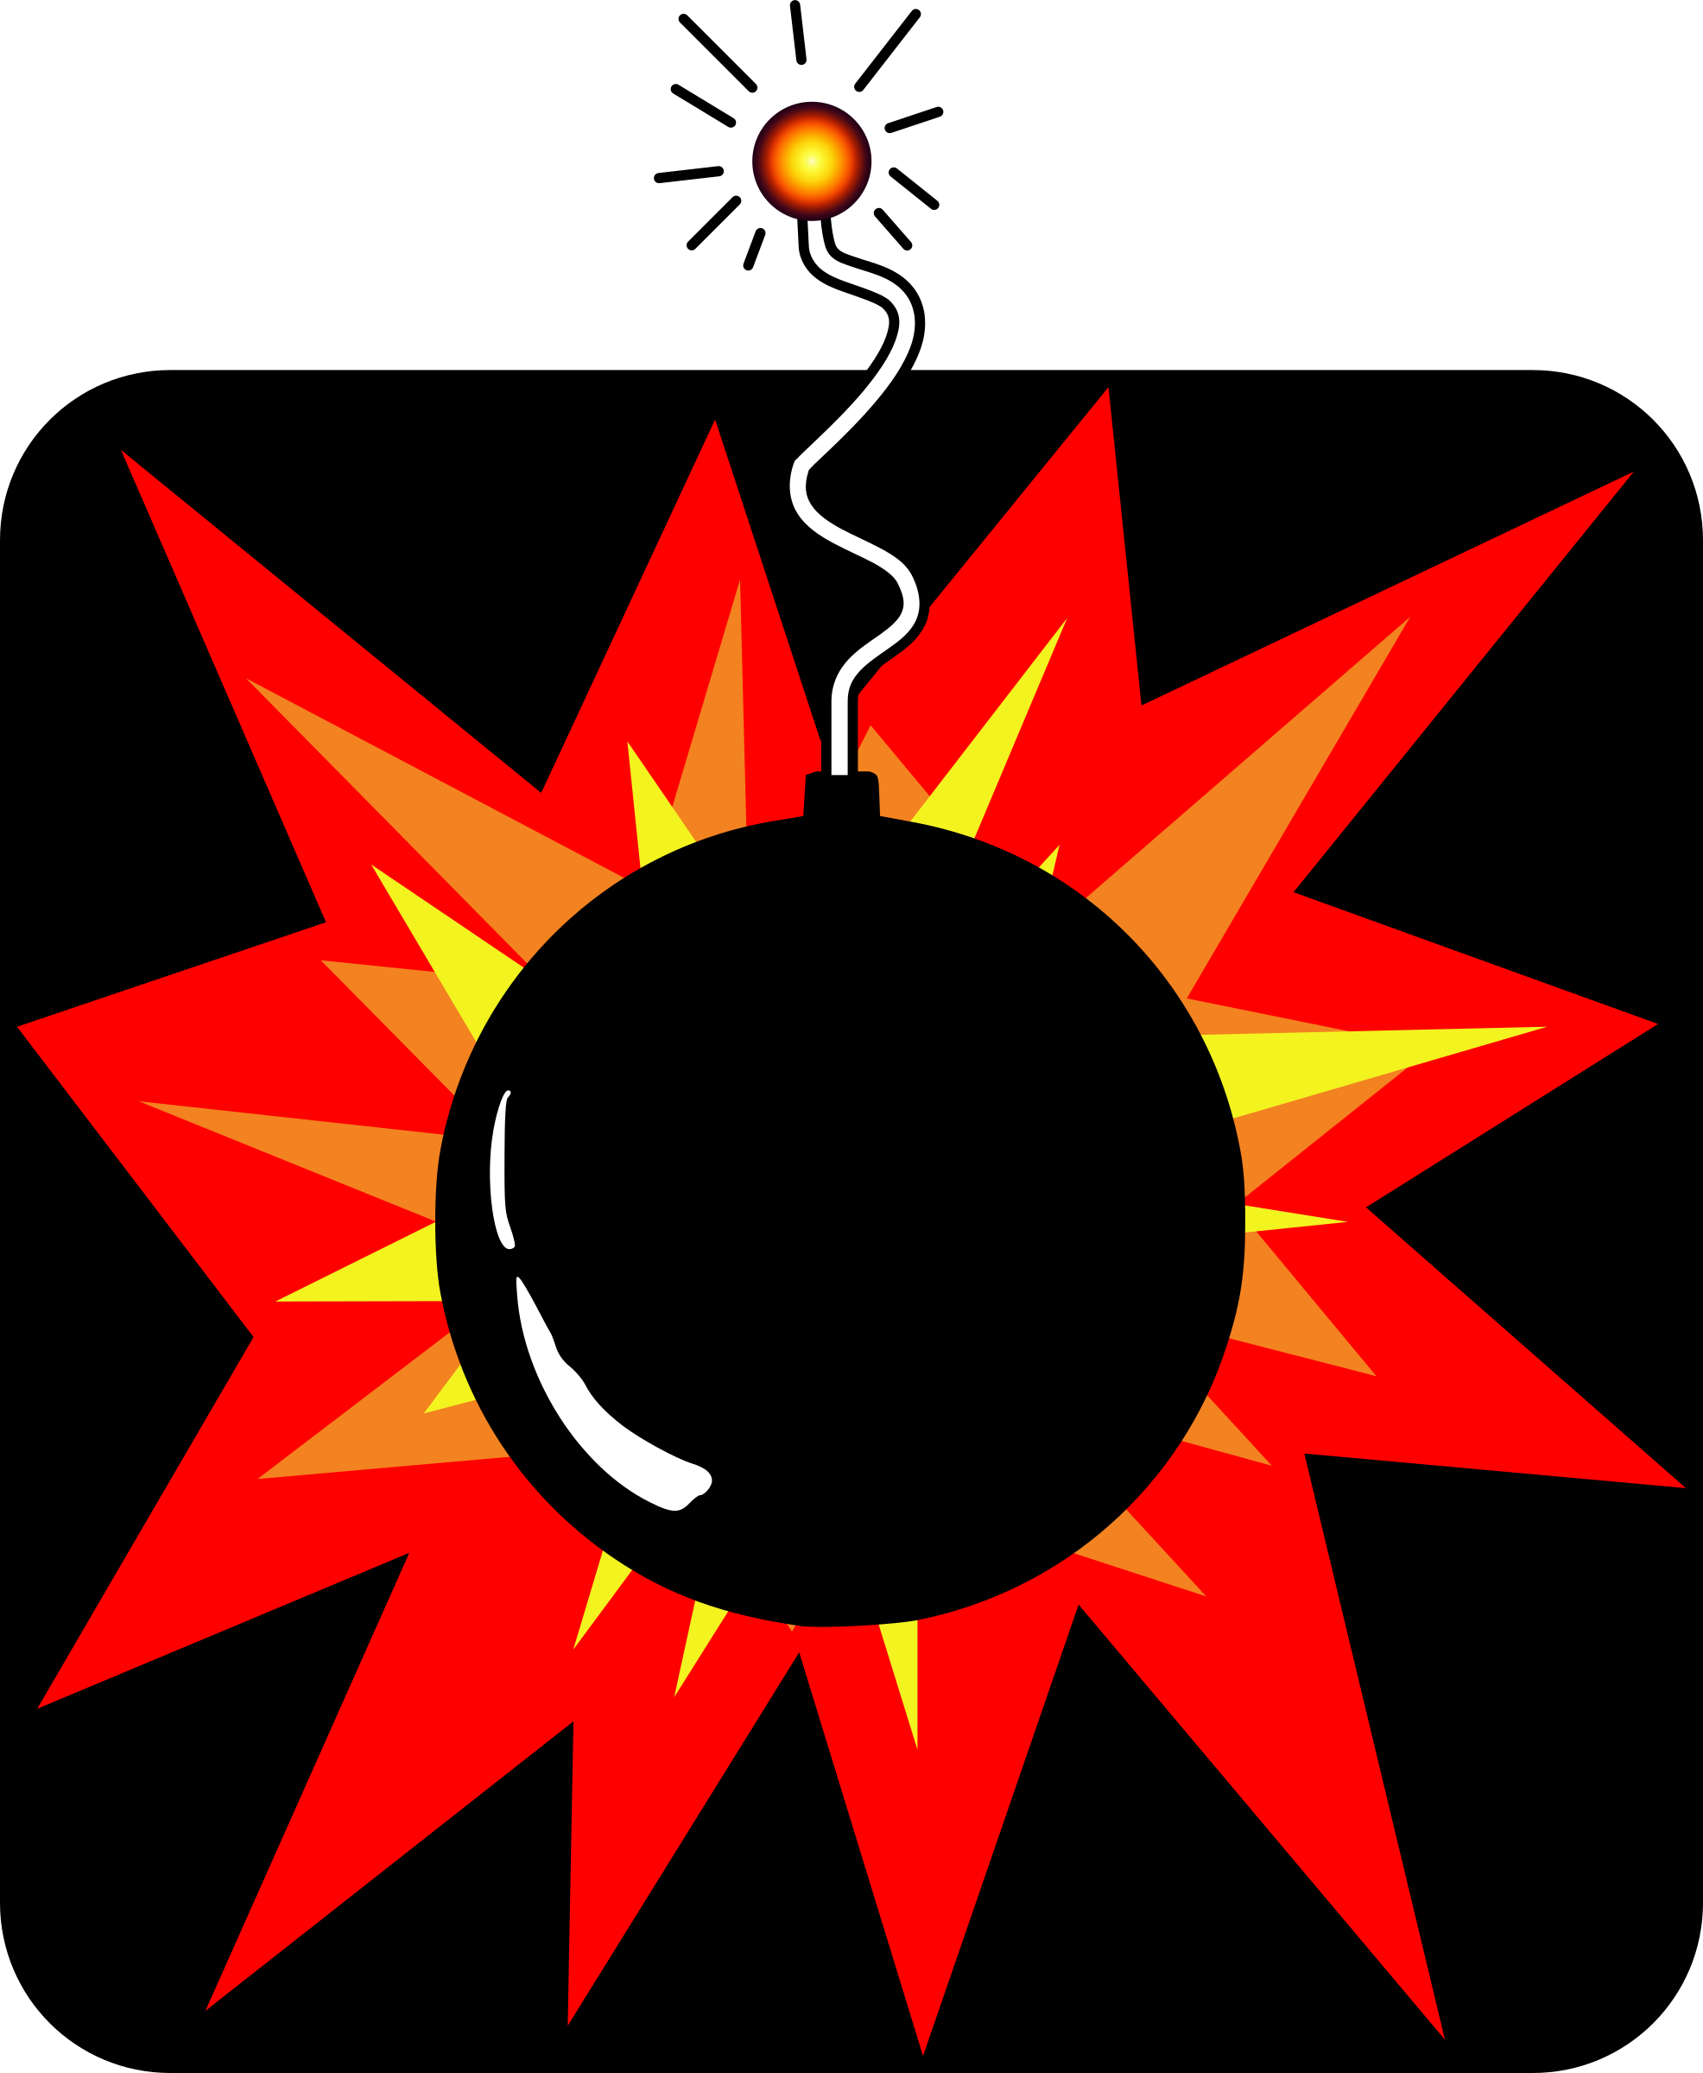

**Code Black: Bomb Threat**

* If you receive a **bomb threat**, immediately notify the supervisor of the unit.
* If you see a suspicious object, do not move or touch the object!

**Code Green Violent Patient**



**Code Green: Violent Patient:** Make sure that a staff member and your instructor are aware that a patient is starting to “escalate”.

**Code White Security Alert/Hostage**



**Code White: Security Alert/Hostage**

If you are taken hostage:

* + - Do everything the captor says to do.
    - Speak only when spoken to. Never make wisecracks.
    - Keep eye contact with the captor(s) but don’t stare. Turn away from captor if ordered to do so.
    - Try not to show your emotions. Captors play on emotional weaknesses.
    - Act relaxed. This may relax the captor(s).
    - Sit, if possible, to avoid appearing aggressive.
    - Tell the captor(s) your first name. This will make you a person, not an object.

If you come upon a hostage situation:

* + Secure the immediate area. If possible, evacuate all non-participants.
  + Immediately report the hostage situation by dialing ext. 5-6165.

**Code Yellow Disaster/Mass Casualty**



**Code Yellow: Disaster/Mass Casualty**

* Wait for instructions from your instructor or a supervisor
* Your assistance may or may not be needed
* Stay in your work area unless instructed to do otherwise



**Code Orange Hazardous Material**

Code White Securityge

**Code Orange: Hazardous Material**

* They away from area that involves the Hazardous Material
* DO NOT attempt to clean up any suspected Hazardous Material
* Notify your instructor or a supervisor if you suspect any unsecured, unsafe, uncontained, or spilled Hazardous Material

**Infection Control**

**OSHA Standards Prohibit**:

1. Eating, drinking, smoking, applying cosmetics, and handling contact lenses in a work area where there is potential for exposure to blood or body fluids.

2. Mouth pipetting of potentially infectious materials.

3. Rinsing or decontamination of equipment in any work area that is not specifically designed and equipped for this purpose. Instruments and equipment are sent to CMS for decontamination and processing.

# Hand Washing

Hand washing is vital to infection control and the best method of preventing the spread of germs from one person to another and from contaminated materials to people.

Basic Principles of Hand Washing:

* Use soap and water for 15 seconds scrubbing all parts of the hand.
* Rinse well.
* Pat dry with a paper towel and use the paper towel to turn the faucet off.
* When using an alcohol based gel, rub gel onto all parts of the hands until they feel dry.

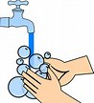

Hands should be washed:

* At the start of your shift and before you leave work
* Before and after patient contact or contact with body fluids
* Before and after eating
* Before and after contact with your eyes, nose or mouth
* After using the restroom
* After blowing your nose, sneezing or coughing
* After removing gloves
* Any time they become visibly soiled

Remember to:

* Keep nails short and well-manicured for easy cleaning
* Remove jewelry
* Wash hands frequently

**Isolation Guidelines**

# Standard Precautions

Standard Precautions is a group of infection prevention practices that apply to ALL patients.

Standard Precautions includes:

Hand Hygiene

Personal Protective Equipment (PPE)

PPE consists of masks, gowns, gloves, goggles and safe injection practices and is available in all patient care areas. Appropriate PPE must be worn if any reasonable possibility of contact with body fluids exists. All body fluids are considered potentially infectious. Lab coats, uniforms and cloth gowns are not considered PPE.

Medications and Food Items may be kept in the same refrigerator/freezer provided they are confined and contained separately. Medications should be placed on top shelves to prevent contamination if spillage occurs. Shelves dedicated for medications should be labeled. Blood, fluid, and tissue specimens may not be stored in the same refrigerators with medications or food.

# Tuberculosis (TB)

* Place a mask on a patient with known or suspected TB immediately.
* Patients with active or suspected TB should be placed in **RESPIRATORY ISOLATION** in a negative pressure room as quickly as possible.
* **Think TB** if the patient has a persistent cough, night sweats, history of exposure to TB, chills, fever, and weight loss.
* TB is transmitted by the airborne route.
* Common transmission mode is coughing.
* The most important method of preventing TB transmission is to teach people to cover the mouth and nose with tissue when coughing.
* Patients/employees who convert from a negative skin test to a positive one should be given prophylactic medications to reduce the risk of infection.
* Employees should wear an N-95 orange duck-bill mask every time you enter the patient’s room.



**Multi-Drug Resistant Organisms**

Patients with **Resistant Organisms** require special precautions.

* An alert is placed on the header of the electronic medical record.
* The isolation status of the patient is noted.
* Limit transfers and notify a receiving department of the patient’s isolation status when transfers occur.
* Review the Infection Control Manual for further information.

**Resistant Organisms** include the following:

* + **MRSA** Methicillin Resistant Staph Aureus
  + **VRE**  Vancomycin Resistant Enterococcus
  + **VRSA** Vancomycin Resistant Staph Aureus
  + **VISA**  Vancomycin Intermediate Staph Aureus

**Additional Resources**

Refer to the **Infection Control BIT** (Bloodborne Pathogens Control Plan, Isolation Guidelines, and TB Control Plan) for additional information. Read and understand your Department Specific Infection Control Guidelines.

# Sharps Safety

* Needles are **not** to be recapped, bent or broken, removed from disposable syringes or otherwise manipulated.
* Broken glass should be handled with broom or forceps and pan, not with hands.
* Sharps are placed in puncture resistant containers. Bone, metal, or glass specimens which may puncture a primary container are placed within a second puncture resistant container.

To Prevent Sharp Injury You Should

* Slow down and be careful
* Ask for assistance when using sharps on patients who are unable or unwilling to be cooperative
* Hold linen and trash bags away from the body and visually inspect them for protruding sharps
* Use a rigid container to hold and transport sharps if disposal container is not nearby
* Replace sharps containers when 3/4 full.
* Always use an appropriate instrument to remove a scalpel blade from the handle and dispose of the blade in a puncture resistant hospital approved container.

# 

# Medical Waste

* Waste that is contaminated with blood or body fluids shall be disposed of in hospital approved contaminated waste containers.
* A contaminated waste box should contain no more than 40 lbs. of waste.
* Items that are not contaminated with body fluids, such as supply wrappers and drink cans, should not be placed in contaminated waste boxes.
* Biohazard labels are not required for laboratory specimens since all specimens are treated as infectious.

**Age Specific Care**

Each age group requires special consideration to ensure their special needs are met. You are responsible for knowing how to provide age specific care for your patients. Be sure to consult with your instructor, nursing staff, reference materials or other resources.

**Falls**

All patients of all age groups have the potential risk for falls. Our objective is to prevent injury and minimize fall risk. If a patient is determined to be at risk for falls, a yellow “Fall Leaf” is placed on the patient’s room door and above their bed. Yellow “Falls” arm bands are also used.

Provide a safe environment for patients. Keep beds in low position, place frequently used items within easy reach of the patient. Keep the room clutter free and properly lit. Educate patients on safety.

**End of Life Care (EOLC)**

All health care workers will have to cope with death and dying issues at some point in their career. There are 4 key elements in EOLC:

* EOLC attends to practical, physical, social, cultural, emotional, and spiritual needs.
* EOLC prevents and relieves pain and distressing symptoms.
* EOLC preserves the patient/advocate’s dignity and preferences.
* EOLC continually assesses and reassesses the patient/advocate’s needs that are intended to help the patient live well though dying.

Patient centered decision making or advance care planning may include provisions for:

Advance Directives

Living Will

Durable Power of Attorney for Healthcare Decisions

“Five Wishes”

Life Support

Hospice

Refusal of Treatment

DNR

Withholding/Withdrawal of Life Sustaining Treatment

Organ Donation

Body Donation

**Newborn Safe Haven Law**

For the purpose of this law a newborn infant is a child not previously subjected to abuse or neglect, who is not more than sixty (60) days old. Ochsner LSU Health Emergency Care Center is the designated point of contact for any parent who wishes to relinquish their infant. Relinquishment means giving over possession or control of an infant to another with the intent to forego all parental responsibilities.

Other facilities where relinquishment is permissible are any state licensed hospital, public health unit, fire or police station, or pregnancy crisis center.

(Refer to Hospital Policy 4.b.19: Relinquishment of Newborn Safe Haven Law)

**“Do Not Use” Abbreviations**

The BRFHH Governing Board has adopted the following abbreviations as prohibited abbreviations. The prohibited list applies to all orders, preprinted forms, and medication-related documentation.

Medication-related documentation can be either handwritten or electronic.

|  |  |  |
| --- | --- | --- |
| Prohibited Abbreviations | **Potential Problem** | **Preferred Term** |
| **U, u (unit)** | Mistaken as zero, four, or cc | Write **unit** |
| **IU (international unit)** | Mistaken as IV or 10 | Write **international unit** |
| QD, Q.D., qd, q.d., Q.O.D., QOD, q.o.d., qod  **(Latin abbreviation for once daily and every other day)** | Mistaken for each other. The period after the Q can be mistaken for an “I” and the “O” can be mistaken for “I” | Write **daily and every other day.** |
| **X.O - trailing zero**  **. X mg – lack of leading zero** | Decimal point missing | - A trailing zero **may be used only when required to demonstrate the level of precision of the value being reported. However, a trailing zero may not be used for medication orders or medication-related documentation.**  **- Always use a zero before a decimal point** |
| **MS, MSO4**  **MgSO4** | Confused for one another. Can mean morphine sulfate or magnesium sulfate. | Write **morphine sulfate** or **magnesium sulfate** |

