(SA)
Ochsner-St. Anne General Hospital
4608 Hwy 1
Raceland, LA 70394
(985) 537-2440
(985) 537- 6841
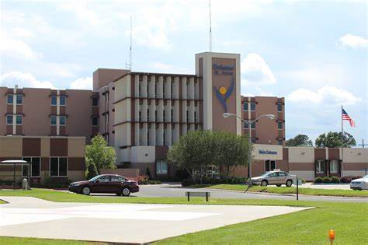
Contact: Cody Walker, CRNA, Clinical Coordinator
Contact Number: (985) 413-0700
E-Mail: cowalker@ochsner.org

Orientation to Clinical Site

- **EXTREMELY IMPORTANT – MUST BE DONE IN ADVANCE**
See forms listed in the Clinical Sites Handbook-Nurse Anesthesia under
Ochsner-St. Anne General Hospital

- Six weeks prior to beginning your rotation at Ochsner-St. Anne, please submit these completed forms via email to MedicalEducation@ochsner.org. Please note, these required forms will only be accepted electronically.

- The THREE forms: Personal Data Sheet, Confidentiality Statement, Student Handbook Form must be completed in the fillable PDF format. Be sure to save your file as to avoid sending blank forms. You must have at least Adobe Reader Version 8. (You may download Adobe Reader for free at http://get.adobe.com/reader/).

- If you have any questions regarding these forms, please contact:
Linda Lambert, Education Program Manager, Student Services
Undergraduate Medical Education
Ochsner Clinical School
1319 Jefferson Highway
New Orleans, LA 70121
Phone: (504) 842-3267

Directions:
- From School: Take I-10 West towards Baton Rouge. Merge onto 310 S, Exit 220, Boutte/Houma. Merge onto US90 West towards Houma. Exit 215 A –Thibodaux /Lockport, LA1 South (keep to the right), 1st traffic light, turn right, and park anywhere in the parking lot
- Student Parking: Anywhere in front of the hospital in the parking lot
- Hospital Layout: The OR is located on the 1st floor, total of 3 ORs (plus one endo room), and L&D
- Scrubs are provided
- Housing: None
- Required Equipment: ID, clipboard, reference books, and evaluation sheets. All other equipment is provided by the hospital
- Free coffee provided by the hospital

Experiences Available to the SRNA
- This is a good rotation for senior students with a lot of autonomy. No MDA and consent for anesthesia is obtained by the surgeon at his office. Anesthesia preop is done the day of surgery. No holding area and patient is brought from his/her room and held outside the OR and this is where the anesthesia preop is usually done.
- OB – c-sections, with administration and management of epidural and spinals; GYN, General Surgery, orthopedics, and minimal pediatrics (ENT).

Patient Assignments
- Patient assignments are received the morning of surgery in the Anesthesia Office. There is a schedule for the next day available by 1400. Since only one student is assigned to this facility, student can have his or her choice
- Patient pre-ops are done by the CRNA or SRNA the morning of surgery. In house patient pre-ops are done the night before.

Daily Clinical Routines
- Report to the OR at 0645 and shift ends when you are relieved by your preceptor or clinical coordinator
- Medication preparation: St. Anne’s now has a Pyxis. It is located in PACU and the CRNA will get medications the SRNA will need for each case. Some backup meds are in the Anesthesia cart but for the most part all drugs are now in the Pyxis
Update - Forms Required - 11-22-2013
Rodney Gisclair, Chief CRNA and Linda Lambert, Education Program Manager
Update- Information regarding case experience revised on 8-1/2018
Jenna Martin, CRNA, DNP
Update- contact information 10/15/19
Jenna Martin, CRNA, DNP
Update- Case Experience 3/29/22
Jenna Martin, CRNA, DNP
Update- Case Experience 1/13/2024
Jenna Martin, CRNA, DNP

