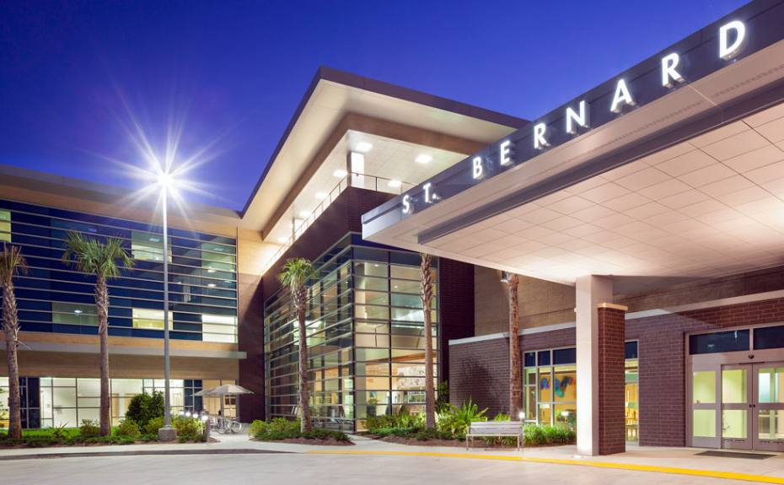
St Bernard Parish Hospital (SBH)
8000 W Judge Perez Dr
Chalmette, LA 70043
504-826-9500

Contact Person: Lloyd Ledet, Chief CRNA
Anesthesia Office: 504-826-9233 ext 4222

Directions to the Hospital:
- We are located on West Judge Perez Dr across the street from Walmart. Coming from LSUHSC-SON, you can take Claiborne all the way to the hospital. It will be on your right. From I-10, exit Paris Rd and turn right on West Judge Perez Dr. The hospital will be on your left.
- Parking is free and in the front of the hospital.
- There are 4 ORs, 2 GI suites, and a Cath Lab all located on the second floor. Upon entering the hospital, go past the Information Desk where there will be two elevators on the right before the cafeteria. Go to the second floor and immediately to the left is a set of double doors leading to the PACU. Push the intercom on the right to be let in. Someone will be there by 630 to let you in. From there, you will be directed to the anesthesia office.
- You will have access to lounge, changing room, and anesthesia office. Scrubs are available. You can wear your own but may be asked to change into scrubs at the hospital.
- There is a cafeteria located on the first floor. After exiting the staff elevator, go right. You will be facing the cafeteria
- There is no housing available.

Orientation to Clinical Site

- IMPORTANT

Initial Contact:
4-6 weeks prior to clinical rotations, you will need to complete and e-mail to Michelle Heisser (cmichelle.heisser@ochsner.org) (Office 504-826-9627), the following forms which are located on the LSUHSC-Nurse Anesthesia Clinical Sites Handbook web page:

- Student Registration Data Forms
- Mid-Level Application Form
- Student Handbook and Handbook Addendum (for your review)

****Please reconnect with Michelle Heisser 2 weeks prior to starting the clinical rotation to confirm completion of necessary requirements. ****

Experiences Available to the SRNA

- Orthopedics (Mondays), general surgery, ENT, occasional vascular and pediatric cases, GYN, Urological, cath lab cases, GI, regional anesthesia, neuraxial, central line insertions (occasionally)
- Fiberoptic bronchoscope and video laryngoscope available

Patient Assignments

- Assignments are posted across from the anesthesia office.

Daily Clinical Routines
0630-1500
- Arrive at the hospital by 0630. Your shift ends when your preceptor dismisses you.
- There is a central Omnicell with several peripheral units
- Most pre-ops are completed the day of surgery in holding. You will be required to assist with interviewing patients
- Ensure that all of the required paperwork is completed, and that the OR nurse has completed his/her interview with the patient prior to administering a sedative.
- You will be required at times to manage patients in the recovery area.

Updated 10/15/19 with nurse educator information
Jenna Martin, DNP, CRNA
Updated 3/29/22 with nurse educator information
Jenna Martin, DNP, CRNA
Updated 12/10/2024 with nurse educator information
Jenna Martin, DNP, CRNA

