Ochsner-St. Charles Parish Hospital
1057 Paul Maillard Road
Luling, LA 70070
(985) 785-6242
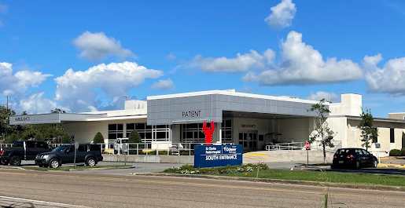
Contact: Jenny Dufrene, CRNA, Clinical Coordinator
Contact Number: (504) 654-9300
E-Mail: jenny.dufrene@ochsner.org

Orientation to Clinical Site

- **EXTREMELY IMPORTANT – MUST BE DONE IN ADVANCE**
See forms listed in the Clinical Sites Handbook-Nurse Anesthesia under
Ochsner-St. Charles Parish Hospital

- Six weeks prior to beginning your rotation at Ochsner-St. Charles Parish Hospital, please submit these completed forms via email to MedicalEducation@ochsner.org. Please note, these required forms will only be accepted electronically.

- The THREE forms: Personal Data Sheet, Confidentiality Statement, Student Handbook Form must be completed in the fillable PDF format. Be sure to save your file as to avoid sending blank forms. You must have at least Adobe Reader Version 8. (You may download Adobe Reader for free at http://get.adobe.com/reader/).

- If you have any questions regarding these forms, please contact:
Linda Lambert, Education Program Manager, Student Services
Undergraduate Medical Education
Ochsner Clinical School
1319 Jefferson Highway
New Orleans, LA 70121
Phone: (504) 842-3267
Or
Michelle Zaiden
michelle.zaidain@ochsner.org

Directions and Information:
- From School: Take I-10 West towards Baton Rouge. Merge onto 310 S, Exit 220, Boutte/Houma. Merge onto US90 West towards Houma. Take exit 7 from I-310 S. Slight right to merge onto LA-18 East/River Rd toward Luling. Follow LA-18 East/River Rd and Paul Maillard Rd to your destination.
- Student Parking: Park on Milling Street and come in the back door (South Entrance).
- Hospital Layout: The OR is located on the 1st floor. Enter the department through the same day surgery waiting area- ring the doorbell to be granted access into the department. Total of 5 ORs, 2 Endoscopy suites, 1 cystoscopy suite, and cath lab. Scrubs are provided.
- Housing: None
- Required Equipment: ID, clipboard, and reference books. All other equipment is provided by the hospital.
- Scrubs: provided by hospital and students must change upon arrival.
- Anesthesia Work Area code: 1-2-3
- All other codes: 2-3-9-1-*

Experiences Available to the SRNA
- GI, Ortho, Cath Lab, GYN, General surgery, Eye urologic, occasional plastics, and pediatric cases.
- No regional administration available

Patient Assignments
- Patient assignments are received the afternoon before day of surgery in the Anesthesia Office. There is a schedule for the next day available by 1400.
- Patient pre-ops are done by the CRNA or SRNA the morning of surgery. In house patient pre-ops are done the night before.

Daily Clinical Routines
- Report to the OR at 0615 and shift ends when you are relieved by your preceptor or clinical coordinator. Most cases begin at 7am.
- Medication preparation: Anesthesia cart and Pyxis in every room.
Initial: Jenna Martin, CRNA, DNP
2/11/2025

