SCHEDULE A FINGERPRINTING APPOINTMENT

Go to this link: AI Scheduler (gsa.gov)

At this screen, start typing “Veteran” and it will bring up “DEPARTMENT OF VETERAN AFFAIRS” (choose that) and continue.

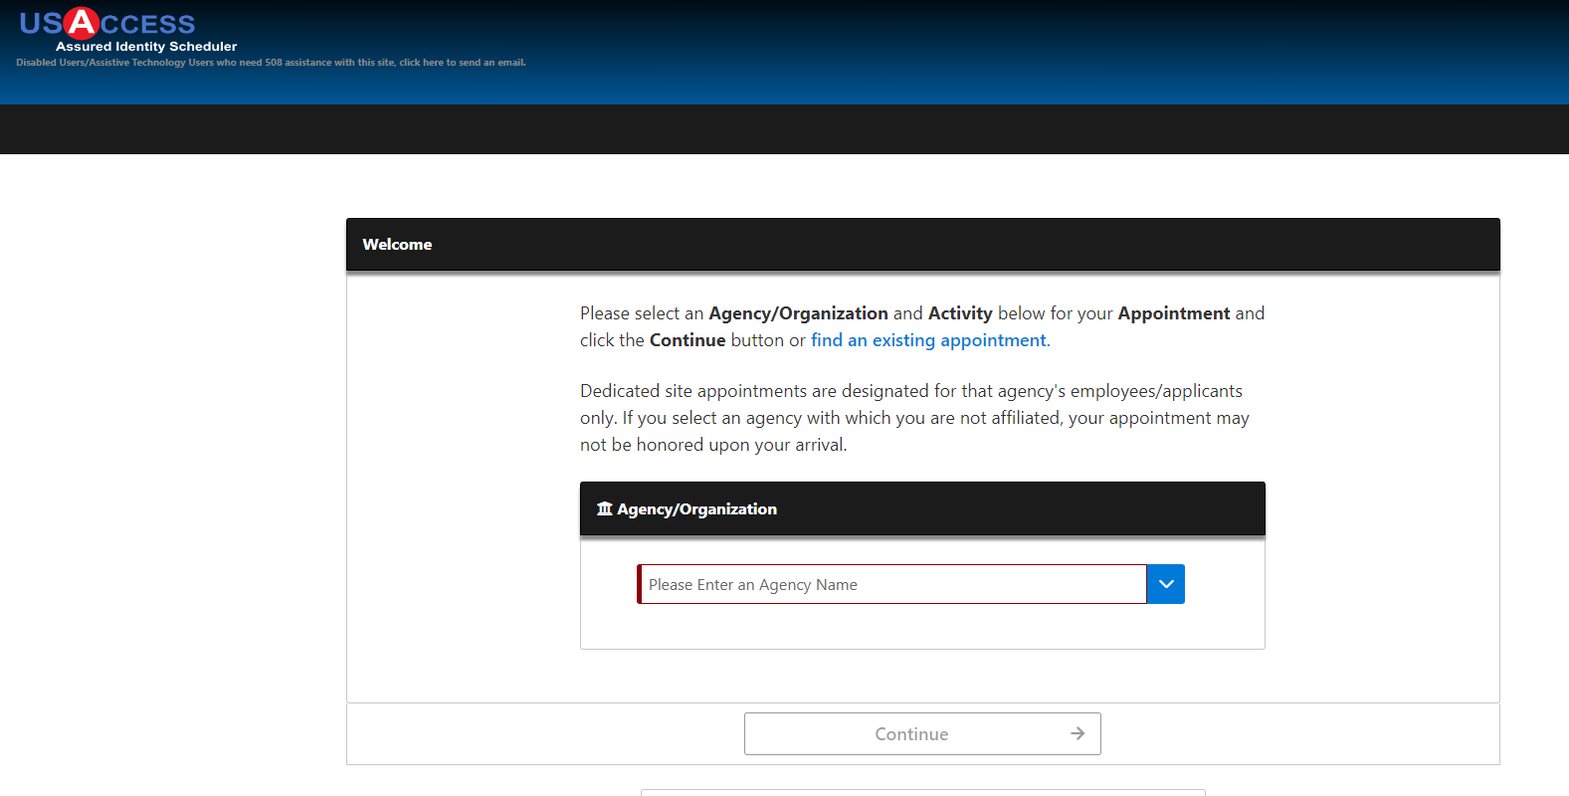

“Enrollment” will already be selected, click “Continue.”

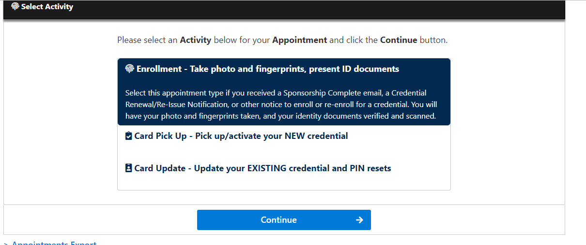

Type in “71101” in the Zip field, then select “Find Locations”
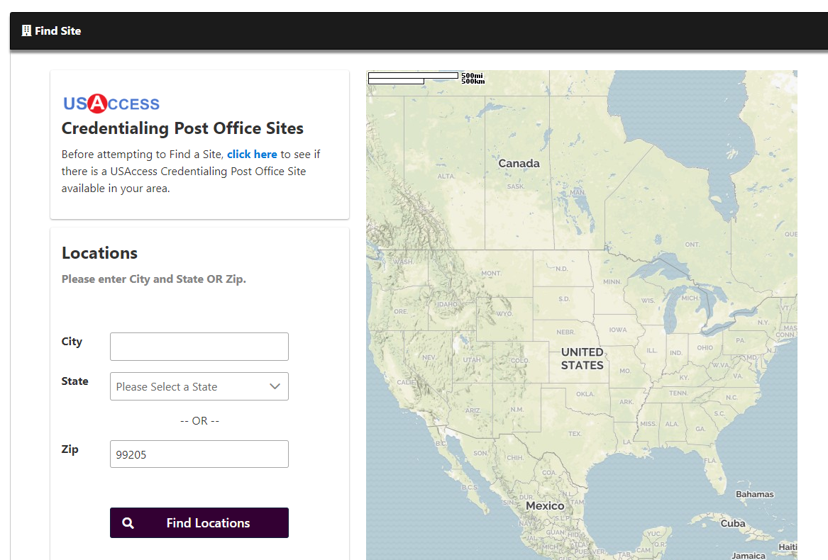

Scroll down and choose “Overton Brooks VA Medical Center”

If you are not physically located in Shreveport, LA, then you will need to pick closest VA to where you are located to make an appointment. Be very clear that you are getting your fingerprints done, but they will need to be transferred to Overton Brooks VA Medical Center. There is a code on the fingerprint form that the person will need to enter into the system. Then be sure to let us know the date, time, and location of where you are getting them done. Also, try to verify they have put your information into the computer correctly. It is of utmost importance, as this is used in every step of the on boarding. If it’s wrong, it is very difficult to fix.

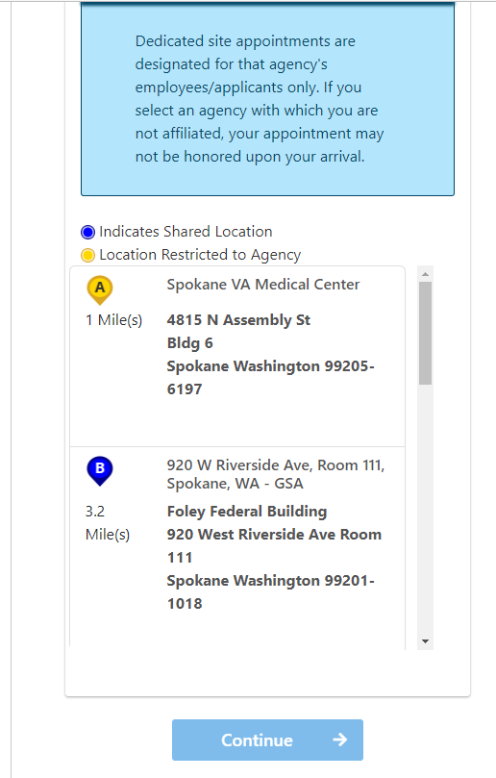

Available dates will have green markers indicating how many open slots there are. Pick a date and time from the calendar and fill in all the information. Please be sure your email is correct when you put it in, as this is how you will be notified. Do a screen shot of your appointment and the confirmation number, just in case you need to reschedule the appointment. Then please send that information to us, so we know when you will be coming on campus. Let us know if you encounter any issues. It is also imperative that you complete your documents in the on boarding tool, so we have enough time to sponsor you BEFORE your fingerprinting appointment.

