Quick Reference –

Codes to Bathrooms -- (next to anesthesia charge office, same day, and across from OR 19)
2468*(star)

Cart Codes- 22662 all green carts that look like anesthesia carts, but not in ORs – outside of OR 8 and in anesthesia
Stock/ work room

Endo/ ECT Cart code—2266 press unlock

Important Numbers-

Trauma MD phone number --504.702.2663
Trauma CRNA # --504.702.2662
** make sure to exchange numbers with the CRNA you are working with each day

Belongings –

Your belongings can be placed in the lockers behind the purple elevators (across from the 4th floor doctor’s lounge). These lockers require that you bring a lock, which should be removed and taken with you at the end of your shift. Because locker space is limited- locks remaining on lockers longer than the designated shift may be cut off and removed.

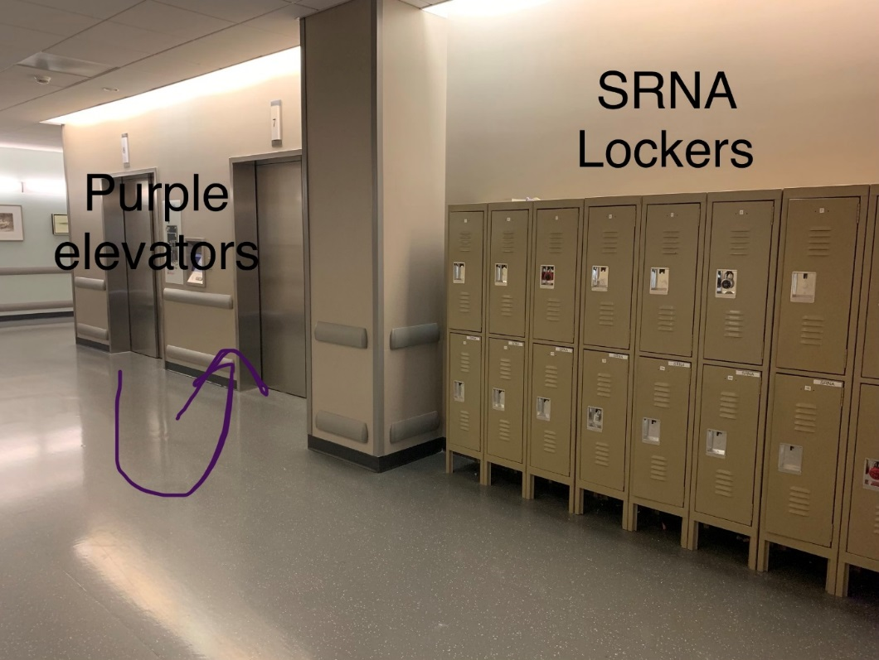

Breaks and Meals- please be mindful of the time you left the Operating Room and return on time- setting an alarm on your phone might be helpful

- Breaks – 15 minutes
- Meal breaks- 30 minutes

- The break room used by anesthesia is located in the hallway on the Operating Room side of the green elevators. If you go through the double doors towards the Operating Room and take a right, the breakroom is the first door on the right. If you have been in the anesthesia breakroom before then you know how small it is. For this reason the break room is typically reserved for CRNAs, anesthesia residents, and anesthesia attendings.

** The SRNAs have been using the break room in between the hallway to Operating Rooms 1-4 and Cath Lab**
- Please be mindful that this breakroom is used by other staff in the Operating Rooms and your behavior reflects on anesthesia as a whole. Try to leave the space in the condition you found it in – wipe up any spills, throw away trash, etc.

Cafeteria Hours:
- Monday - Friday
  - 6:30 am - 10:00 am Breakfast
  - 10:00 am -11:00 am Grab and Go (prepared foods)
  - 11:00 am - 2:00 pm Lunch
  - 2:00 pm – 4:30 pm Limited Lunch
  - 4:30 pm – 6:30 pm Dinner

- Saturday & Sunday
  - 6:30 am - 10:00 am Breakfast
  - 10:00 am – 11:00 am Grab and Go (prepared foods)
  - 11:00 am – 6:30 pm Lunch/Dinner

***So if you’re here for an evening or overnight shift plan accordingly***

PJs Hours:
- 6a- 1am- these are the hours they have listed on the UMC website, but I have seen them closed during these times, so try not to depend on them for meals if/ when cafeteria is closed

Menchies Hours:
    - Monday- Friday
      - 11:00 am - 8:00pm
    - Saturday & Sunday
      - 12:00 pm - 8:00pm

When you arrive in the Operating Room at the beginning of your shift-

- Check your assignment in the anesthesia charge office (occasionally assignments change overnight)

- Place circuit on machine and run a machine check

- Check suction- there should be a clean liner and lid

- Ambu bag- should be hanging behind anesthesia machine

- O2 tank on back of machine with PSI > 500

- Make sure Eschmann is available in case of unexpected difficult airway

- O2 Tank- Make sure your room has an O2 tank (with oxygen in it) with a carrier. UMC policy requires that O2 tanks are transported with a rolling carrier. They are not to be placed on the bed next to the patient. They can be placed in the O2 tank holder on the bed, but keep in mind that unless the tank belongs to the patient (as in you took the O2 tank from the ICU when you picked up the patient and you plan to leave it there, you will need a carrier to return the tank to the OR). The same thing goes for tanks on the stretchers, we try not to exchange empty tanks on stretchers with full tanks from the rooms because there simply aren’t enough tanks stocked in the OR. So even though it is less convenient and difficult, we have to hook the tank and carrier on the stretcher and roll to PACU, same day, etc.

- Prepare an intubation/ airway setup (or roll) for the first case
  - Full intubation/ Case setup includes the following:

- ETT
- Stylet
- 10cc syringe attached to pilot balloon
- Oral airway and tongue depressor
- MAC and Miller blade with handle-- (ensure handle light is working and bright— no need to open the blade to check the light – you can simply press the light with your finger to check it)
- Esophageal stethoscope
- BIS monitor
- Bair Hugger (Upper/ Lower)
- Face Mask
- NGT if necessary

- Prepare syringes
- 3cc- versed, Zofran
- 5 cc- fentanyl, rocuronium, lidocaine
- 10cc- etomidate, succinylcholine, neo-synephrine, ephedrine, vecuronium
- 20cc- propofol
- neo-synephrine 10mg to 100cc bag (100mcg/cc) or 250 cc bag (40mcg/cc)
- Make sure syringes are labeled appropriately (drug, concentration, date, time, initials)

- Check supplies to ensure you have what you need for the day

When you arrive in the Operating Room at the beginning of your shift (continued) -

- Check soda lime – To refill soda lime- open canister, remove and place the sponge to the side on top, dump exhausted soda lime in garbage, pour new soda lime into the container – the container should be full but not too full- remember you want air to be able to flow through the soda lime. Replace sponge on top, wipe any condensation and debris 6/14/2019 from rim of container and close. Soda Lime is located in the anesthesia supply/ work room on the shelving unit to the right with the pillows.
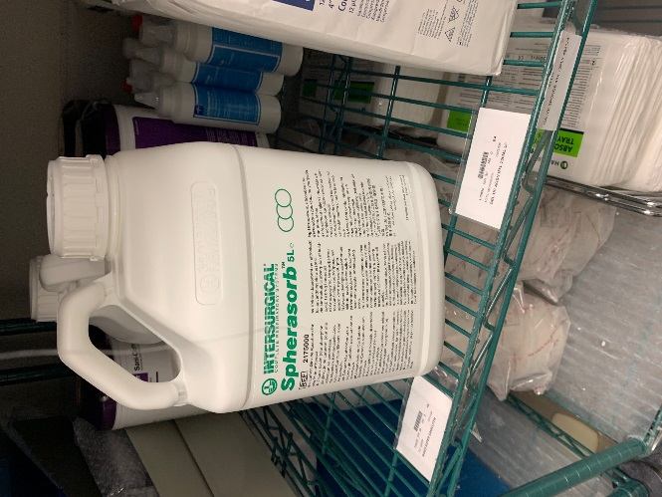

- Make sure room has IV pump and channel(s)

- Make sure room has Bair Hugger Machine

- If necessary- setup A-line and 2nd fluid

- Ensure LMAs are stocked in your room ( 2 of each size)—think of your emergency airway algorithm
- Remember where the emergency airway equipment is located- outside of the trauma room (OR 8) and in Core 2 (on the core side of Operating Room 8

Deciphering the Operating Room board/ Locating your patient-
- One Day Surgery (ODS) = Same Day = Pre/Post (slots numbered 10 – 20 & 30-40)
- Endoscopy pre/post (slots numbers 1-9 & 25 (ish) -29)
- Cath Lab (slots 21-25 (ish))
- PACU (slots 1-21)
- Pre/Post Inmate area (slots 41-45 (occasionally) and slots 48-54 (always))
- Slot 46/47 no longer exist as they were converted to the future bronchoscopy/ EBUS room (not in use yet)

- The Operating Room surgical board is color coded
  - White (and listed in an Operating Room (not listed on the add-on board))- not called for, but scheduled to go in given Operating Room
  - Yellow- called for- Patient may be in waiting room or in the process of transferring from room to same day/ preoperative area
  - Orange- Patient is now in same day/ pre-op, but not ready to go to Operating Room yet (may need an IV, H&P, meet and greet, site marked, etc.). There will be a small number all the way to the right on the Operating Room board identifying the patient’s location.
  - Pink- Patient is ready for Operating Room according to preoperative area.
  - Blue- case completed
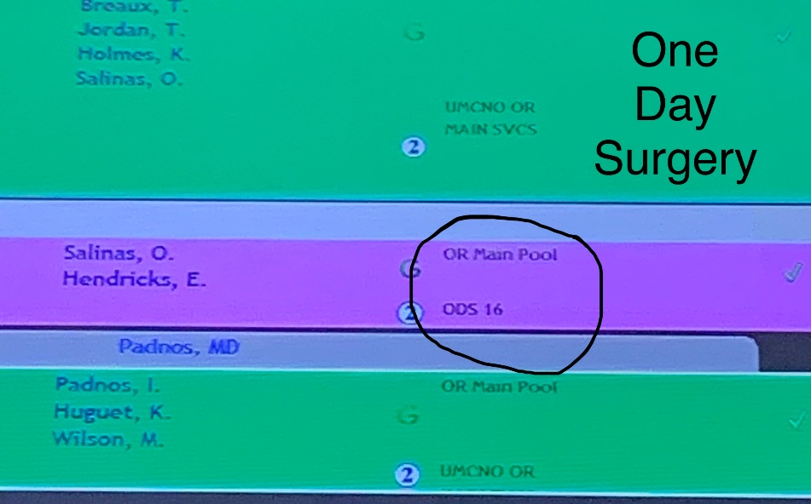

Pt is in One Day Surgery (ODS) slot 16.

Operating Room assignments-

This is just a general list of the type of cases that go into each room during normal OR
(630a-3p) hours, all bets are off after 3, on nights, and on weekends. So if you are setting up a room for
a case on an off shift, to be safe it’s probably best to ask the charge nurse where they plan to put the
case.

OR 1- GYN
OR 2- GYN and plastics
OR 3 – Plastics
OR 4 – Eye cases, dental (not OMFS), and general
OR 5- GU and occasionally hand cases
OR 6- General and GU
OR 7- GU and robotic cases
OR- 8- Trauma room
OR 9- Ortho trauma room
OR 10- Ortho room
OR 11- Ortho room
OR 12- General Surgery
OR 13- CV, Vascular, and backup trauma (alternates between OR 13 & OR 14)
OR 14- CV and vascular
OR 15- ENT and Gen surgery
OR 17- OMFS
OR 18- Burns, Gen surgery, and 3rd neuro room when necessary
OR 19- Neuro
OR 20- Neuro

ICU patients coming to Operating Room -

- If you have time it is always a good idea to walk over to the ICU and see the patient before going over to roll to the Operating Room - this will give you the most accurate information.

Things to note:
- IV access (peripheral vs. central (PICC vs CVC)
- A-Line
- Intubated- if so note vent settings and amount of PEEP (bring PEEP valve to connect to Ambu bag for transfer)
- Drips infusing
- Overall condition of patient – is there anything that might need to be addressed prior to transfer to the Operating Room?
- Ask the ICU nurse about antibiotics that may be due- we only have a few antibiotics stocked in the omnicell and if you have to call pharmacy once you’re in the OR, the wait can be long.

When going to ICU to bring patient to Operating Room:
- Bring fluids (blood tubing plus extension is usually a sufficient fluid set up)
- O2 tank
- Drugs needed (versed, fentanyl, paralytic – if patient is intubated)
- Bring bedside monitor from ICU to monitor patient during transfer
- Do not bring any controlled infusions (fentanyl, versed) to Operating Room

When returning patient to ICU from Operating Room:
- Bring O2 tank back to Operating room
- Use ICU bedside monitor for transfer
- If any drips are infusing, make sure to return or exchange pumps with ICU. The goal being to make sure we have pumps available in each OR. So if you leave a pump with two channels with patient, make sure you return to OR with a pump and two channels. You can exchange pumps or transfer drugs to ICU pumps.

Off Unit –

**Always make an intubation setup in these rooms in the event you need to convert during the procedure**

- Cath Lab (4th floor) - if you are standing at the Operating Room front desk, take a right and walk all the way down the hallway, you will run into Cath lab area.

- IR 2- General Interventional Radiology Cases
- IR 3- Neuro Interventional
- Hybrid (IR 6) - should always be set up for a trauma case, minus spiked fluids
- EP (IR 7) - Electrophysiology lab

- Endoscopy Suite (where colonoscopies and upper GI endoscopies are performed)- (4th floor) down the same hallway as the locker rooms/ bathrooms and CRNA breakroom- walking in the direction of the clinic side of the hospital as opposed to the direction of the Operating Rooms.

  - Endo 1 – regular endo room
  - Endo 2—regular endo room
  - Endo 3 – regular endo room
  - Endo 4—ERCP room, but also do regular endoscopy cases as well.

- Endobronchial Ultrasound (EBUS) - (4th floor)-fourth floor purple tower, scan id and when doors opens take a left and then a quick right. Down the hall across from the nurses station is the room we are doing bronchoscopies and endobronchial ultrasounds. The machine stays in that room (at one time we were moving it back and forth). There is a cart with supplies, but always double check stocking in this room as it can be overlooked.

- CT scan – (3rd floor) Take a left after getting off the green elevators on the third floor and walk down the hallway until you reach a set of double doors, scan your badge and take the first left- straight ahead is the pre-/ post- area for CT scan. There is usually someone at the desk or in the room with information about where the scan or interventional case will be done. There is an anesthesia cart and machine in the hallway past the mammogram area (the CRNA will help you find the cart and show you where to go, just wanted to give you a very rough idea of where CT scans are performed)

- MRI—(3rd floor/ 4th floor) fourth floor around the corner from OR 20—MRIs performed on the 3rd floor are in the same general area as the CT scans, thus the anesthesia cart is used for supplies.

- ICU (4th floor MICU (4100s (purple tower)/ TICU (4200s (purple tower)) – the cases we are called to the ICU for are usually GI cases.

Things to bring for these cases include:

- Fluids
- Cart – usually bring the ECT cart (as it has supplies and a computer that connects to WI-FI (unlike the carts in endoscopy)
- Drug box

- Electroconvulsive Therapy (ECTs) - (4th floor) ECTS are performed in the Pre-/ Post- area (PP 41-54) on Monday, Wednesday, and Friday mornings. They start at 630am and usually the night shift is in that area until the day shift arrives to take over. All ECTs are General Anesthetics

ECT setup:
- Ambu bag
- ETCO2 in-line sample to Ambu and monitor
- Suction
- Airway set-up
- Fluids (usually 500cc bag)
- Emergency drug box
- Oral airway, nasal trumpet
- Soft bite guard

- Transesophageal Echocardiogram (TEEs) - (4th floor) TEEs are performed in pre-post 22- 25(ish).

TEE setup:
- Ambu bag
- ETCO2 in-line sample to Ambu and monitor
- Suction
- Airway setup (roll)
- Fluids (usually 500cc bag)
- Emergency Drug Box

Dropping Patients off in Post Anesthesia Care Unit (PACU)/ Recovery Room-

- Below is just a general list of information that may be of interest to PACU RN-
- Brief history- pertinent medical and surgical history
- Versed
- Narcotics
- Antibiotics
- Anti-emetics
- Fluids
- Blood loss
- Urine output
*** Always ask if there is anything else they need or if they have any concerns or questions ***

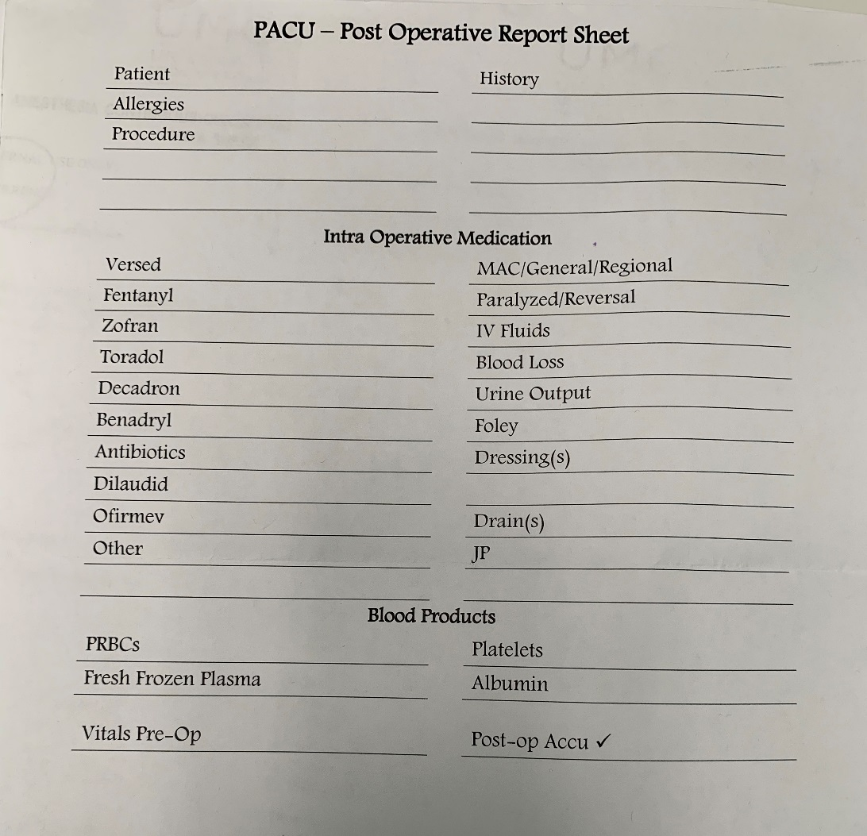
Emergency Equipment - see photos next page

- CMACs- kept in core 2 (between OR 8 and OR 12)

- Bronchoscopes- also kept in core 2, but in order to open the case a key that is found in the OR 8 Trauma room Omnicell- so someone with access to Omnicell will need to help you

- McGrath/ Videolarangoscopy with blades- hallway outside of OR 8 / Trauma room in green cart. (code: 22662)

- Glidescope Go – hallway outside of OR 8 in the same cart as McGraths

- Airway bags (blue bags and small black one) - contain supplies for emergent intubations, code blue calls, and for some off unit cases when an anesthesia cart isn’t available (MRI, 3rd floor CT scan/ interventional). The top pocket should contain a clean, unopened roll. If you accompany the CRNA to any of the aforementioned events- please remember to replace any items used to ensure the bags are always stocked and ready to go in an emergency

- Emergency medication boxes- in the top two drawers of the green cart across from OR 8. We also bring these boxes to emergent intubations, code blue calls, ECTs, TEEs and for off unit cases. Again please** – please remember to replace any items used to ensure the bags are always stocked and ready to go in an emergency

- Pediatric Cart and Pediatric Airway Cart- across from OR 8 and OR 16
- Neonatal Cart – across from OR 8
- Malignant Hyperthermia Cart- across from OR 8
- Ultrasounds- across from OR 8

Emergency Equipment (continued) –

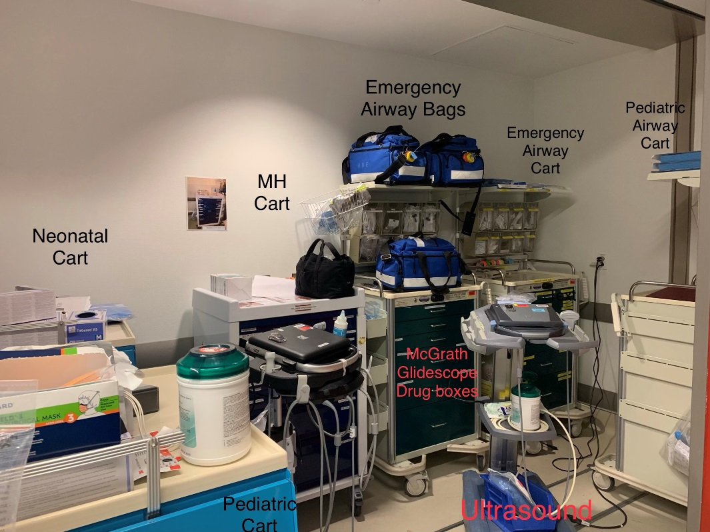
Outside of Trauma Room (OR8) - Across from the OR front desk, inside the double doors

Emergency Equipment (continued) –

Outside of Trauma Room (OR 8) – On the core side
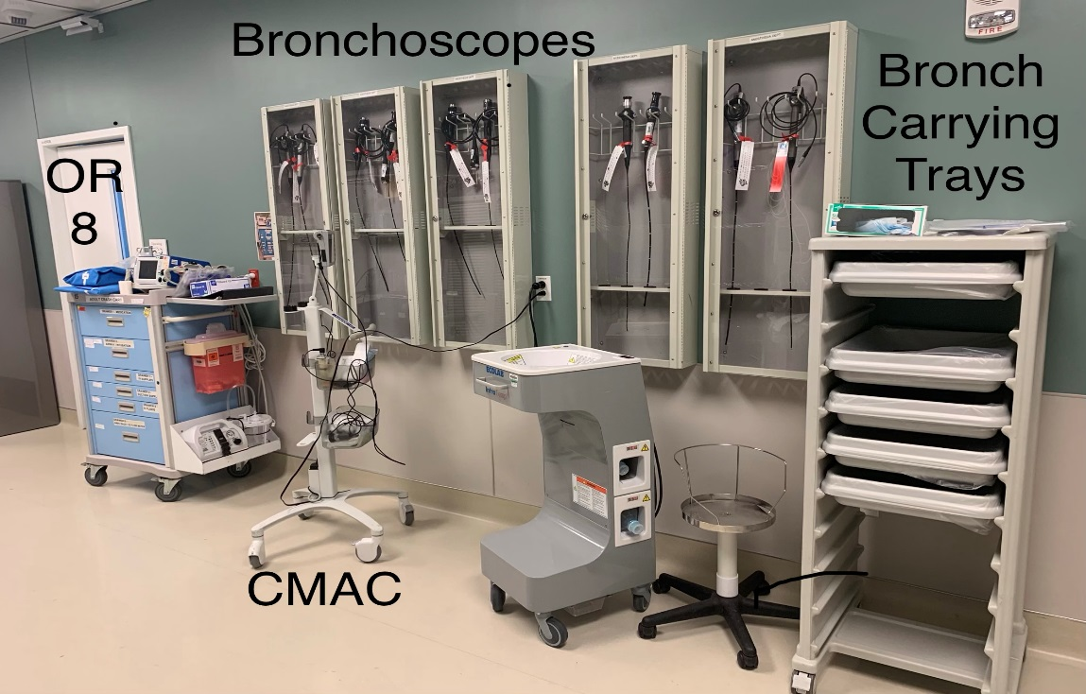

- If you are bringing a bronchoscope to an OR (or anywhere for that matter). Place bronchoscope in carrying tray

Emergency Equipment (continued) -

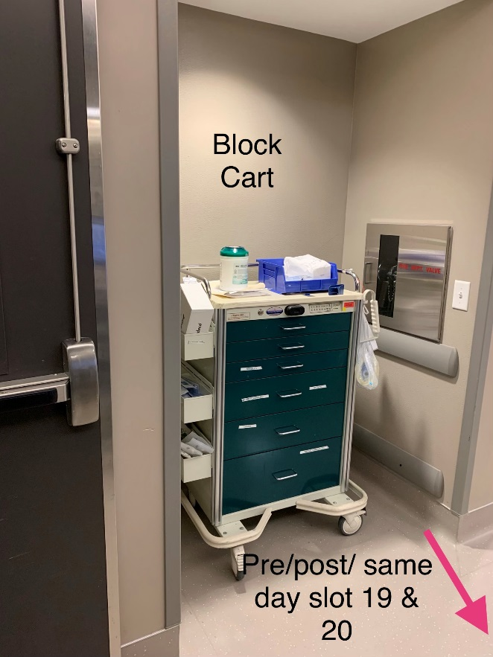
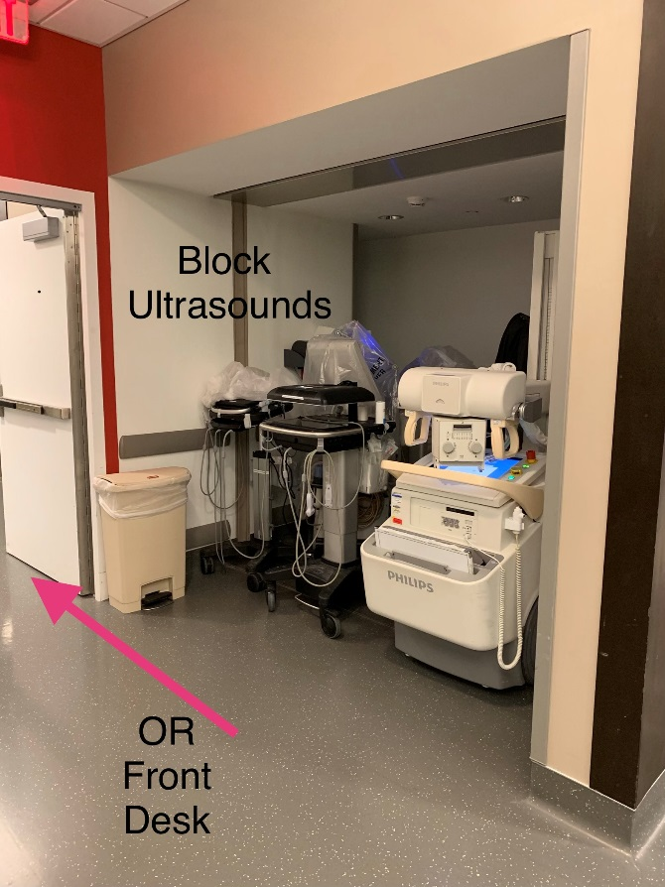

Stocking-

Anesthesia stock/ work room is in the back hallway in between core 1 and the hallway to ORs 5-7

Anesthesia Cart—

--First Drawer
- Blood band armbands * 1 pack
- Chlorohexidine swabs small * 4
- Saline flushes- in order to stock these look in the cores near where fluid is stocked
- Off-line paperwork
- ABG slips

-- Second drawer
- Needles of various sizes
- Insulin syringes *5
- Mannitol filters *2 (may stock more than 2 in Neuro rooms, trauma, and CV rooms)
- Lancets for blood glucose monitoring
- 3 way stopcock w/ swivel male luer lock * 8
- VAMP needless shielded cannula * 5 (A-line sample port adapter)
- Tape – 2in silk/ 2in paper * 4, 1 in silk/ paper *4, pink tape * 4
- Eye Dressings
- Blood tubes- light green (BMP, troponin) * 4, Blue (coags) * 4, purple (CBC)* 4,
- Pink (blood typing) *4
- 60 cc syringes * 2

−−Third drawer
- Yankauer * 4
- Skin temperature sensor * 5
- Nasal Trumpet 7 *2, 7.5, 8.0, 8.5, 9.0
- KY jelly packets * ~ 20
- Tongue depressors * ~ 20
- Sims connector (used to attach NGT to suction) * 4
- Oral airways –pink/ yellow *2, 90 * 5/6, 100 * 5/6

−− Fourth Drawer
- BIS strips * 5
- EKG leads
- Suction catheters (14 Fr *3, 16 Fr *2, 18 Fr * 2)
- NGTs (14Fr *2, 16 Fr * 3, 18 Fr *2)
- Stylets * 10
- ETT- 5.5 *2, 6.0 *2, 6.5 *2, 7.0 * 3, 7.5 * 3, 8.0 *3, 8.5 * 2, 9.0*2—may need additional
small tubes in ENT room and additional large tubes to EBUS room

Stocking List (continued) -

−− Fifth Drawer
- Micro drip tubing/ gravity set *2
- Secondary tubing *2
- Blood infusion set * 5
- Pump infusion set * 6
- Multiport extension set * 2 (aka manifold, scorpion, crow’s feet)
- Large, hand pump tubing (Y – type blood/solution set with filter and pressure pump) * 2/3
- Extensions * 6
- A-line set up * 2
- 500cc pressure bag * 2
- A-line extension tubing-- 32 in *2, 84 in * 2
- Chlorohexidine tegaderms * 4/5

--Sixth Drawer
- Nasal cannula * 4 (the clear nasal cannula is used with the anesthesia machine (MAC
- cases in OR and the NC with the green tubing and orange connector for monitoring
- ETCO2 are for endoscopy (except for endo 4 which has anesthesia machine set up) and off unit)
- Face Mask * 7
- Nebulizer Setup *2
- Upper body Bair Hugger *5
- Lower Body Bair Hugger *5

−−Right side of cart
- Basket
->LMAs 3 *2, 4 *2, 5*2
- Bucket
-> Circuit extensions * 2
-> Circuits * 4/5
-- Left side of cart
- Top shelf
-> Aline starting supplies (Arrows and Argon Kits)
- Second Shelf
-> Blood filters * 10
- Bottom Shelf
->Canisters * 5
-> Lids * 5

Stocking List (continued) -

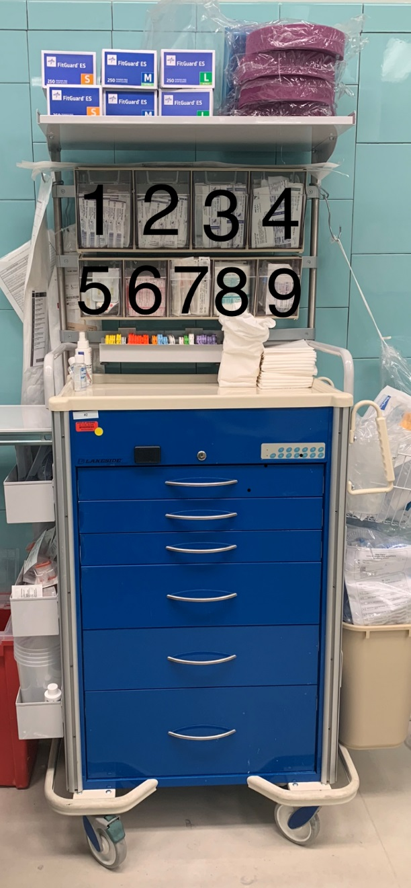
- 3 cc syringes
- 5 cc syringes
- 10 cc syringes
- 20 cc syringes
- Misc
- Blunt needles
- Jelcos (14 fr-22 Fr)
- Tegaderms (large/ small), alcohol prep
- IV start kits x4, Saline lock catheter extension sets x2

** Keep cubicles closed when not in use **
Stocking List (continued)

Anesthesia Machine—

--Top of cart- purple Sani-wipes *1 and hand sanitizer

--Top drawer of anesthesia machine
- MAC 3 * 4/5
- MAC 3.5 * 5
- MAC 4 * 5
- Miller 2 * 5
- Miller 3 * 3
- Extra handle
- C batteries *2
- 9 Volt battery *1
- Nerve Stimulator *1
- D-fend *
- Scissors * 1
- Clean setup roll- everything should be clean and unopened

--Second drawer of anesthesia machine
- Accordions * 6
- Fiberoptic bronchoscope swivel Adapter *2
- ETCO2 Gas sampling line 10’ with male leur connectors *6
- Goggles * 2/3
- Peep valves *2
- Dental protectors * 2
- Head strap * 1/ 2
- Nasal atomizer * 2
- Mcgills * 1/ 2

--Third drawer of anesthesia cart
- Extra cords
- Pressure Cables ( A-line/ CVP)
- Caps for anesthesia gas ( Isoflurane/ Sevoflurane)
- Flashlight with extra D batteries

--Fourth drawer of anesthesia cart
- Narrow/small BP cuff *2
- Regular BP cuff *5
- Long BP cuff *5
- Pulse ox *8
- Nasal pulse ox * 2

Stocking List (continued) -

Omnicell Machine-

--Top of Machine –Keep boxes closed when not in use
- 3cc syringes
- 5cc syringes
- 10cc syringes
- 20cc syringes
- Blunt needles
- Iv start kits
- Jelco (14g, 16g, 18g, 20g, 22g)
- Radiopaque Jelcos (16g, 18g. 20g, 22g)
- Saline locks/ Catheter extension set

--Inside Machine
- Fluids to bottom drawer
  - 1 L Lactated Ringer’s * 8
  - 1 L Normal Saline *8
  - 500 cc NS *4
  - 250 cc NS* 5
  - 100 cc NS * 5
** the Omnicells in ORs 8, 9, 13, and 14- have more emergency/cardiac drugs so you probably won’t have room for all of the above fluids, but most other rooms have space available.
- Isoflurane, Sevoflurane, Desflurane

Additional Stocking Notes-

- Discard anything that is open (unless you opened it and know how long it has been open (this is a JCAHO stipulation. I know this is wasteful, so keep this in mind before you open something you aren’t sure you will need)
- Return supplies that you didn’t use. For example, if you brought a 37 and a 39 Double Lumen tube to do a case, but only used the 39, return the 37 to the anesthesia workroom. Supplies can be limited. We don’t want necessary supplies stashed in the anesthesia cabinet of an unknown room when we need to do an emergent case.

Anesthesia Stock/ Work Room – Located on the back hallway (facing Tulane Ave and parking garage) in between Core 1 and the hallway to ORs 5-7.

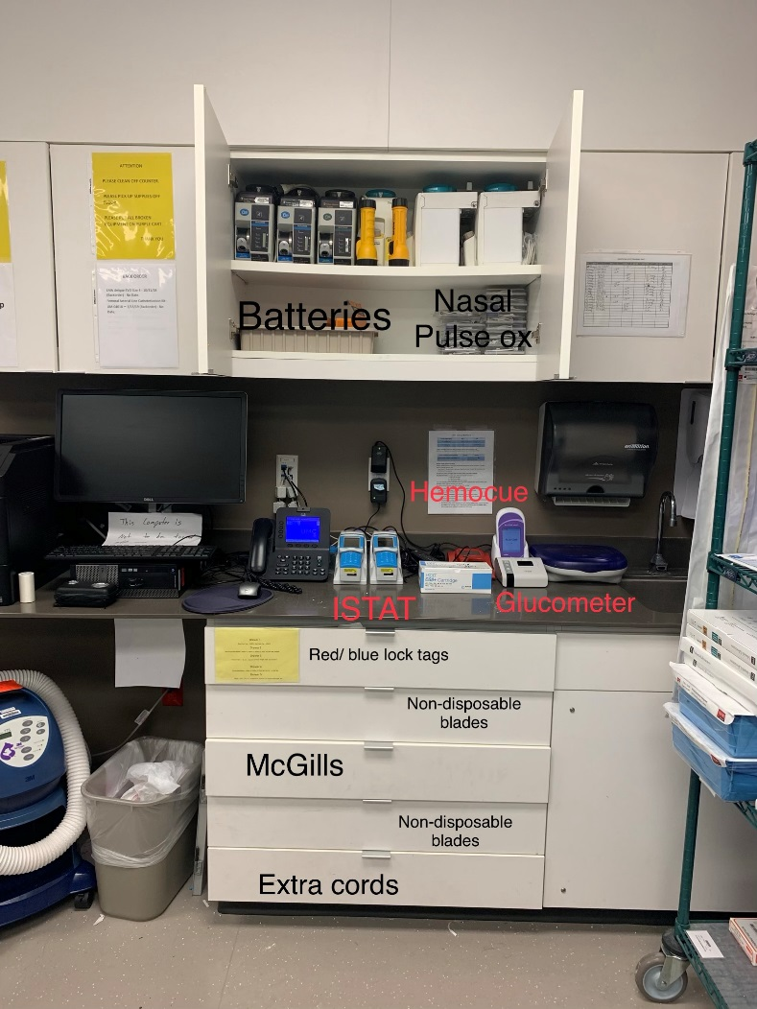

Anesthesia Stock/ Work Room (continued) –

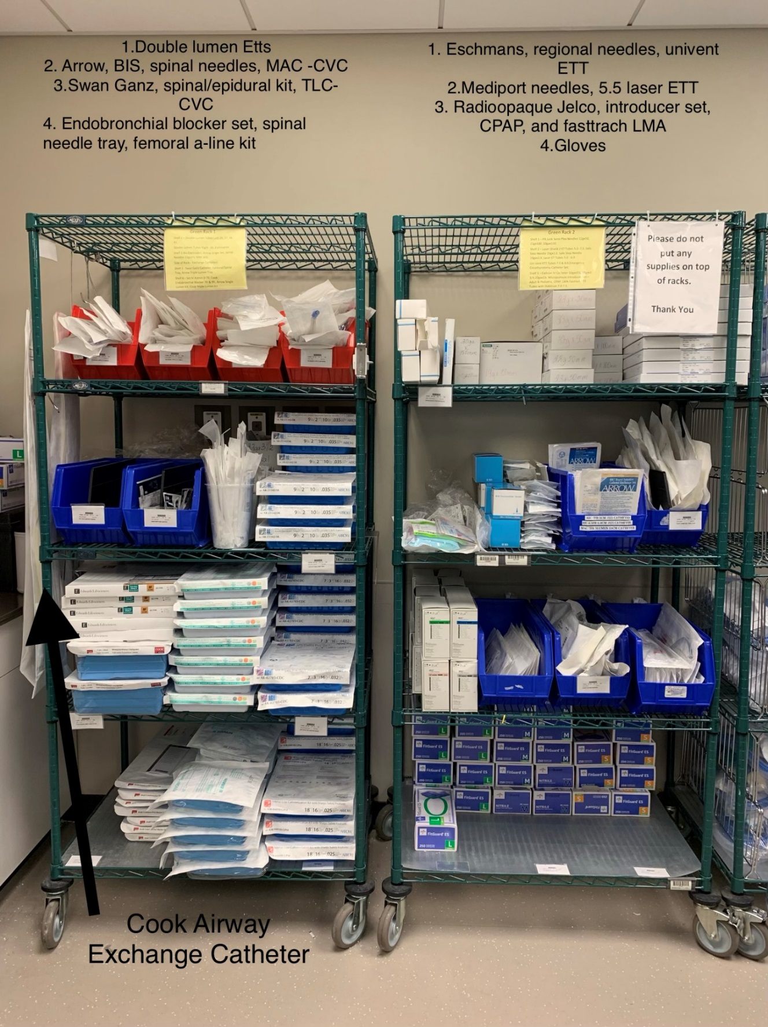

Anesthesia Stock/ Work Room (continued) -

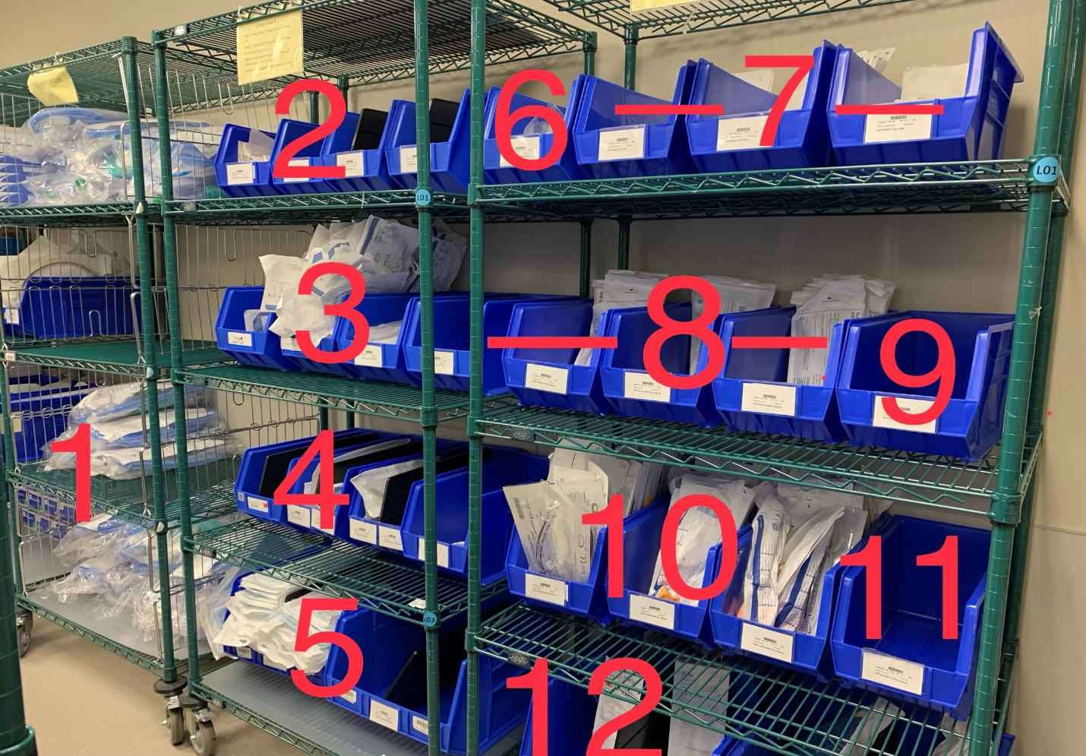

- Circuits
- Nasal Raes- various sizes
- Oral Raes- various sizes
- Reinforced ETTs
- Upper/ Lower Bair Hugger
- Microdrip tubing
- Suction catheters (14 Fr, 16 Fr, 18 Fr)
- NGTs (14 Fr, 16 Fr, 18 Fr)
- 500 cc Pressure Bags
- LMAs 0 various sizes
- Y- tubing with hand pump
- A-line kits

Anesthesia Stock/ Work Room (continued) –

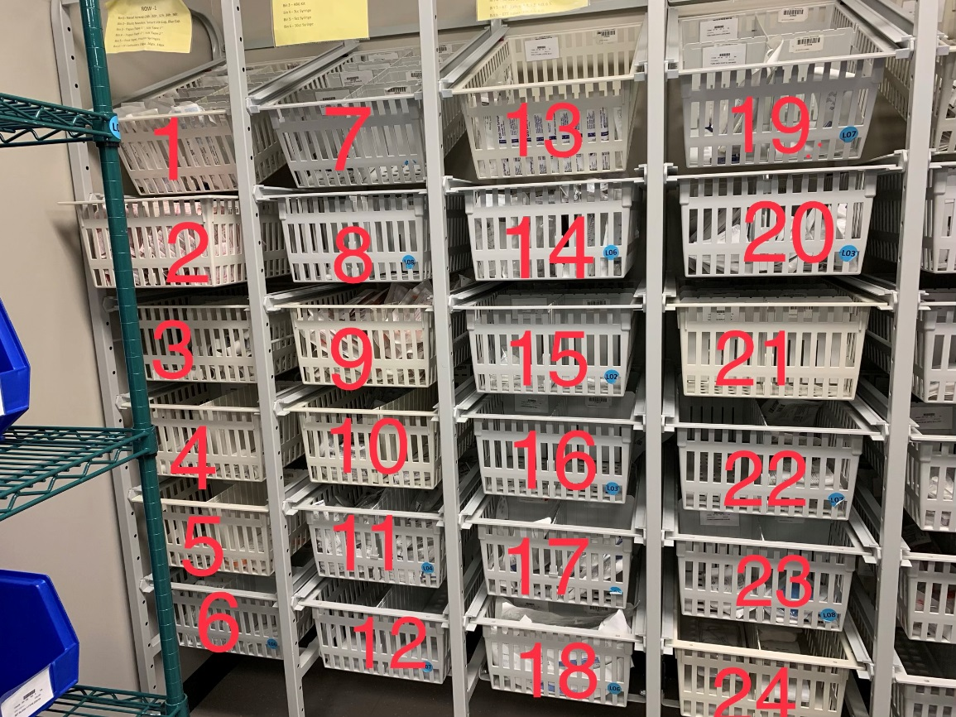
- Nasal Trumpets
- Blunt needles, needle free IV connector, Luer lock cap
- 1 inch paper tape, 1 inch silk tape
- 2 inch paper tape, 2 inch silk tape
- Pink tape (for securing ETT), insulin syringes
- Jelco (14g, 16g, 18g)
- Jelco ( 20g, 22g, 24g)
- IV start kits, iv tegaderms, regular tegaderms
- Arterial line blood sampling kit
- 3 cc syringes
- 5 cc syringes
- 10 cc syringes
- 20 cc syringes
- 30 cc syringes, 60 cc syringes
- Accordions ( extendable extension tubing), NGT connectors, fiberoptic Bronchoscope swivel adapter
- Oral Airways (9 cm, 10 cm)
- Endotracheal tube (5.5, 6.0, 6.5)
- Endotracheal tube (7.0, 7.5, 8.0)
- Endotracheal tube (8.5, 9.0)
- Pulse ox sensors
- 36 in/ 84 in pressure tubing (A-line extension), pressure tubing adapter
- Single pressure tubing setup with venous arterial blood management protection (VAMP)
- Ultrasound transducer cover, triple pressure monitoring setup
- Argon A-line kit
Anesthesia Stock/ Work Room (continued) -

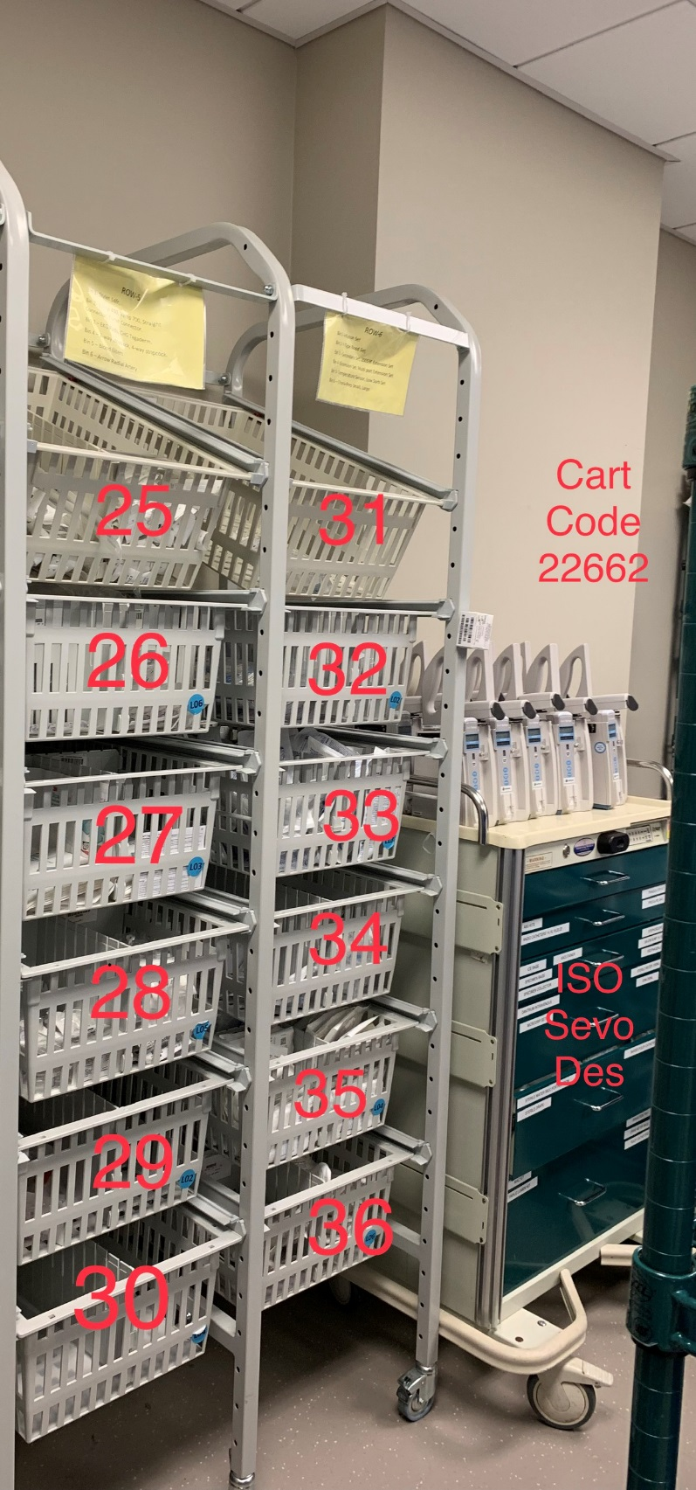

- Stylets
- Vamp cannula/ A-line port sample,
Misc.
- CHG tegaderms, EKG leads
- 3-Way stopcocks
- Blood Filters
- Arrow Radial artery catheterization set
- Alaris pump tubing
- Alaris blood pump tubing
- Secondary tubing, catheter
extension set (saline lock)
- Extension set, multiport extension set
- Skin temp sensor, yellow striped
micro bore infusion set
- Chloraprep (small and large)

Anesthesia Stock/ Work Room (continued) –

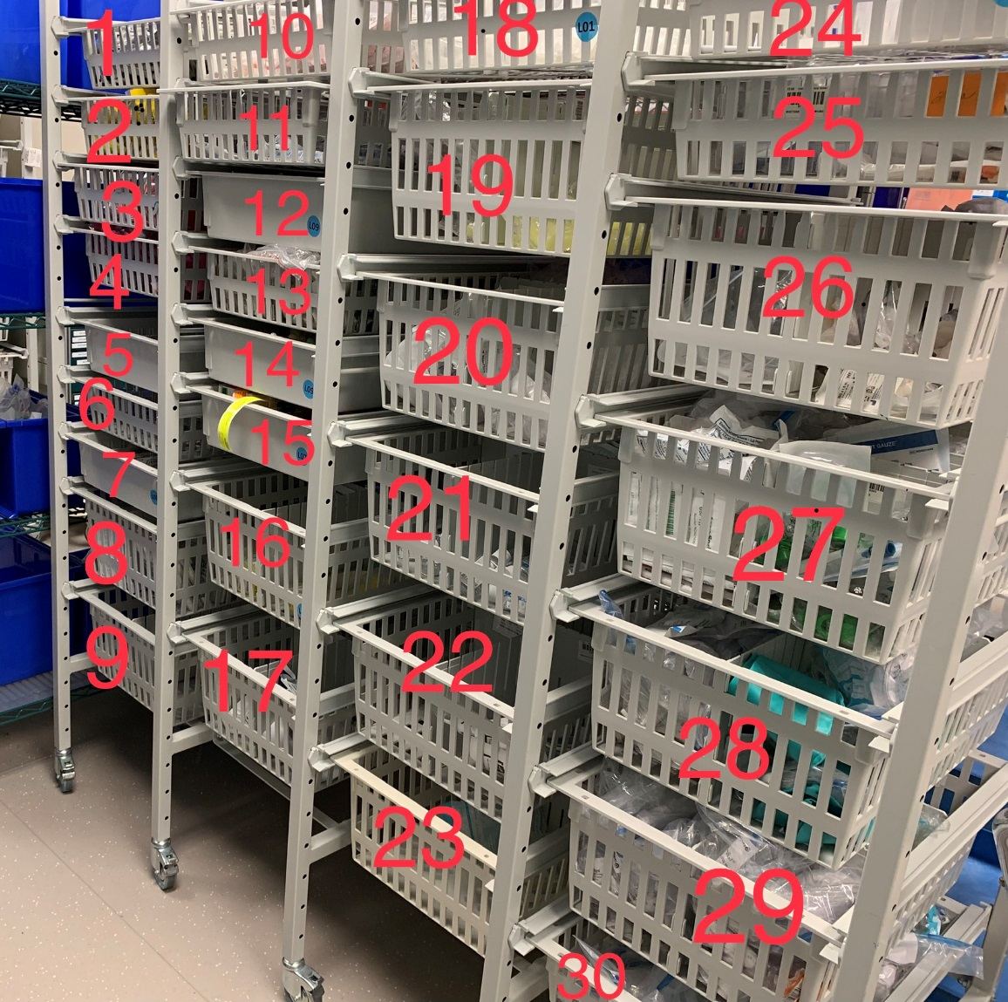

- Miller 2 Laryngoscope blade
- MAC 3 Laryngoscope blade
- MAC 3.5 Laryngoscope blade
- MAC 4/ Miller 3 Laryngoscope blade
- KY Jelly, alcohol prep pads
- ETCO2 sample lines, Y type catheter extension set
- Tongue depressors, face straps for mask
- Regular adult BP cuff, Small adult BP cuff
- Long adult BP cuff
- Needles (20g, 21g)
- Needles (23g, 25g)
- Radiopaque Jelcos (16g, 18g, 20g, 22g)
- Curos caps, adult tooth protectors
- Vacutainer test tubes (pink, purple, blues, green)
- Daily Stickers for IV tubing and fluids
- Blood bands, tourniquets
- Adult colorimetric CO2 detector, iGuard eye protection goggles
- Small oral airways
- Yellow oral airways, pink oral airways
- Peep valves, multi adaptor for ventilator circuit/ ETT
- Hand sanitizing gel, small bore extension set
- Yankauers, PCA administration set
- Misc.
- Millipore filters (Mannitol filters)
- Trach masks, Misc.
- Misc.
- Misc.
- Misc.
- Misc.
- Misc.

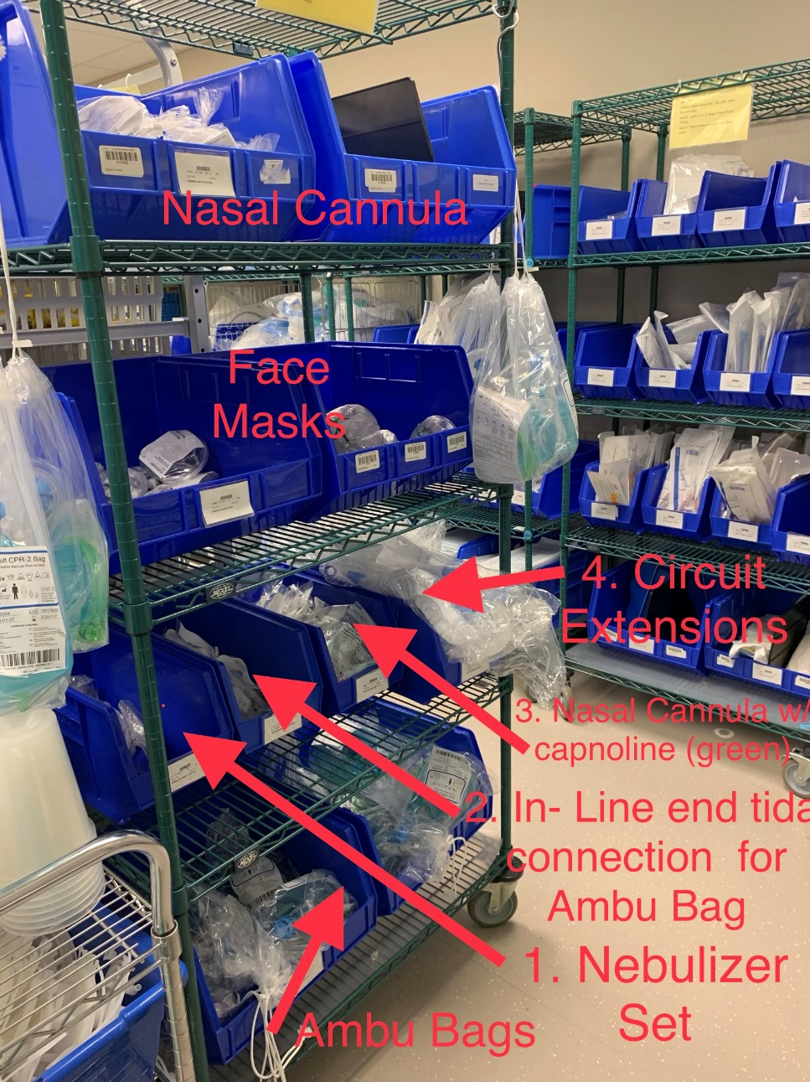
Off- Shifts (any shift other than Monday- Friday 6am-3pm)

- Report to anesthesia office- write your name and phone number on dry erase board
- Get assignment and report to room if assigned
- If your OR is finished before your shift is over, make sure the CRNA has a way to contact you in the event another case is added or if another room becomes available. I’m sure you’ve noticed how small the front anesthesia office is and how chaotic it can be with a ton of people standing around, so devise a plan with your CRNA regarding breaks, stocking, studying, etc. Checking in every once in a while if you haven’t heard anything is always appreciated

- If you come in for an evening/ night shift and there are no cases going. The following is a list of things that need to be done at some point during the night:

- Check ORs for the following:
  - O2 tank
  - Bair Hugger
  - Pump with channels
- Check trauma rooms:
  - OR 8 – Primary Trauma Room
    - Machine check performed that day
    - Full setup/ roll on anesthesia machine including BIS, NGT, A-Line supplies, IV supplies -- supplies do not need to be opened, but they should be laid out on anesthesia machine and ready to go
    - A-Line setup
    - IV Fluids primed and ready with hand pump tubing and one extension- primed and labeled with appropriate day change stickers
    - Level one primed and ready to go (labeled with appropriate stickers)
    - Underbody warmer on bed
    - Room should be well stocked- paying careful attention to saline flushes, A-Line sample kits, ABG slips, Mass Transfusion paperwork, syringes, blunt needles, blood filters, and fluids

  - Backup trauma room (usually OR 13 or 14)—should be setup and stocked as described above minus spiked fluids
  - OR 19 – should be setup and stocked as described above minus spiked fluids
  - Hybrid- down by Cath lab – should be setup and stocked as described above minus spiked fluids
- Check with the charge CRNA re: big cases for the following day and preparing fluids and A-line
Set-up, etc. in respective ORs
- Sunday, Tuesday, and Thursday night- set-up for ECTs the following morning
- Consents for in house patients- a physical exam and interview is part of this process, so bring your stethoscope and something to write notes about the exam. Probably a good idea to take a quick look at the patient’s history in Epic so you know what questions are pertinent to that particular patient.

Misc. Information

Call Rooms –

- The call rooms the SRNAs utilize are on the 5th floor in the purple tower (room #s- 5300s). Your ID badge is required to access this area. There is a card in the anesthesia front office that is required to scan into the individual call rooms. There should be a post –it note stuck to the card indicating the rooms the card will access. If there are multiple students on a given night shift, those not holding the card will need to prop their call room door open to return to their individual room.

Parking Validation –

- Make sure you bring your ticket from the garage in with you (i.e.: don’t leave the ticket in your car)
- Go to the security office in the Emergency Department – all the way at the end of the hall, walking in the direction of S. Claiborne

