Please contact 2 weeks prior to your rotation:
Jamie Hunt
Email: ansoffice8149@gmail.com
Office: (225) 924-8149

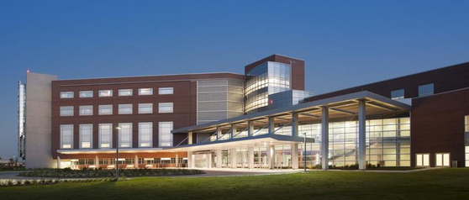

Woman’s Hospital Main Campus
9050 Airline Highway
Baton Rouge, LA 70815
(225) 927-1300
www.womans.org

Clinical Coordinator: Courtney Bagot, MD
courtneybagot@hotmail.com

Clinical Coordinator: Mario Perez, CRNA
Cell: (225) 955-5565
mperezcrna@gmail.com

Administrative Assistant: Jamie Hunt
ansoffice8149@gmail.com
Office: (225) 924-8149
Fax: (225) 924-8448

Orientation to Clinical Site
- Students are asked to phone anesthesia office secretary prior to going to this site.
- Students are encouraged to look up directions on a map search engine for driving directions. Students may park in the employee parking lot, which is ungated.
- There are 12 ORs located on the second floor of the hospital. Labor and Delivery department is on the second floor.
- Students should report to the anesthesia office on the second floor by Labor & Delivery. Students will be expected to arrive at 10:00 am on the first day and at 06:00 thereafter.
- OR times begin promptly at 07:00 and scheduled C-sections will go back 30 mins before scheduled time (Example: 0630 for a 0700 C-Section)
- If you are unable to attend clinical for any reason, you must inform the OR front desk and leave a message with the anesthesia office before your shift. The anesthesia office does not open until 8:00am. The student is also (as always) required to contact LSU school program director if unable to attend clinical.
- Orientation is provided the first day of clinical. The student is expected to fill out paperwork for pyxis codes and facility access. The facility requires you to bring: RN state license, ACLS, BLS, PALS proof.
- The length of rotation at this facility is usually 2 months, with any change being the discretion of the school faculty. Facility provides all needed equipment. Student will be expected to wear school id and lab coat to clinical. The facility requires students to change into scrubs at site for entrance into second floor ORs. The Labor and Delivery floor does not require students to wear facility scrubs.
Experiences Available to the SRNA

- The student will receive anesthesia experiences in GYN, general, plastic, and ENT surgical cases.
- High volume of OB management cases including C-section and labor management.
- Neonatal surgeries are performed at this facility (approx. 300/yr); however, students must have special permission for these cases.
- Epidural and spinal anesthesia management (not administration) is offered at this facility.

Patient Assignments

- Students will pick up assignment the morning of surgery. Surgery schedule is posted at the OR desk. You will be expected to turn in care plan to school faculty for this facility.

Daily Clinical Routines
0630 - 1500 Shift

- Report to clinical at 0630. Pick up assignment at the OR desk, and set up room. Student will see patient in Day of Surgery for preop if necessary. Otherwise the circulator will bring patient to OR. Surgery begins at 0700.
- Breaks are provided at the discretion of the preceptor. Lunch breaks are half an hour in length. Students are given a 25% discount in the cafeteria for lunch.
- Students will be dismissed when cases are completed or at the discretion of the CRNA preceptor.

Lodging and Meals

- Baton Rouge has many dining facilities and coffee shops.
- LSU main campus is located on highland road and has a library with internet access. Other public libraries are also available in town.
- Housing: No housing is available at this time.
Updated: 08/31/2022 Jennifer Badeaux DNP, CRNA
04/4/2023 Jenna Martin DNP, CRNA
05/15/2023 Paul Barras DNP CRNA
06/04/2024 Jennifer Badeaux DNP, CRNA

