Very important things to do:
- You must ALWAYS introduce yourself as a senior student from LSU in the anesthesia program and working with a CRNA. We have had several problems with patients who find out after the fact that a student treated them and were not happy. Envision has even had to reimburse patients due to this. Not introduce yourself, as a student will result in you being excused from the site.
- You must always wear your badge on your collar of your shirt so that it is visible to patients and employees. If you do not have your badge on you will be asked to leave for the day.
- Please review the obstetric section of your VARGO app (If you do not have the app, consider downloading it). Even if you have not had obstetrics, you should have a general knowledge of obstetrical anesthesia for this rotation.
- Please call me before your rotation begins.
  - Doug Francois CRNA --Cell number is 337-780-1100
  - You are expected to be here by 06:15 am or earlier if it takes you longer to set up.
Epidurals:
- We bolus with 0.2% naropin; usually 5-10cc based on height. The CRNAS also put 100mcg of fentanyl in the epidural.
- Use 0.2% naropin for infusion using PCEA pump.
  - We run usually 12-16 based on height.
  - The PCEA dose is usually set for 5 ml every 30 min to 1 hour.
Cesarean Section (patient has epidural in place):
- If we go to a section we bolus with different options after we test the level on the patient.
  - Some use the pump, manual bolus.
  - Others use 2% lidocaine or 0.5% bupivicane or a combo of the two. The amount given is based on the patient’s current level.

Students should know and understand:
- What layers they are going through? 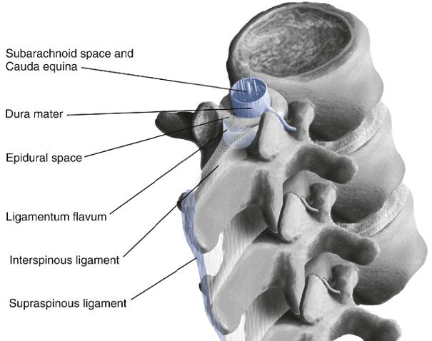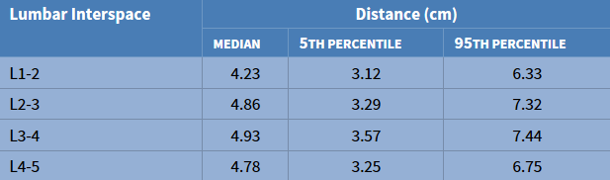
- What level to do regional and why?
  - The spinal cord ends at the level of the bodies of L1 and L2 in most patients, the subarachnoid space and cauda equine continue to the S2 level. Inserted usually in the L4 level, but may go up or down a level.
- What the test dose is testing for
  - Epidural catheter placement may be complicated by blood vessel or dural puncture with the needle or catheter. To prevent possible local anesthetic toxicity and high or total spinal anesthesia, the anesthesia provider must recognize the unintentional intravenous or subarachnoid placement of the needle or catheter. The purpose of the test dose is to allow early recognition of a malpositioned catheter. A negative response to an epidural test dose does not guarantee the correct placement of the epidural catheter in the epidural space, nor does it guarantee that the catheter is not malpositioned in a blood vessel or the subarachnoid space. Rather, it decreases the likelihood that the catheter tip is in a blood vessel or the subarachnoid space
- What signs or symptoms we look for when giving the test dose?
  - Vascular (3 cc of lidocaine 1.5% with epi 1:200,000 )
    - Increase in heart rate of 20 bpm within 1 minute and/or an increase in systolic BP between 15 and 25 mm Hg
    - Tinnitus, circumoral numbness, “dizziness”
- Intrathecal
  - Motor blockade at 3-5minutes
- Steps to Decrease Fisk for Unintentional IV or Subarachnoid Injection
  - Lower the proximal end of the catheter below the site of insertion. Observe for passive return of blood or CSF
  - Aspirate before injecting each dose of local anesthetic.
  - Give the test dose between uterine contractions.
  - Use dilute solution of local anesthetics during labor.
  - Do not inject more than 5 mL of local anesthetic as a single bolus.
  - Maintain verbal contact with the patient.
  - If little or no block is produced after the injection of an appropriate dose of local anesthetic, assume that the local anesthetic was injected IB and remove the catheter.
- How to measure the catheter to determine placement at the skin?
  - You want 3-5 cm in the epidural space. A few ways to determine depth
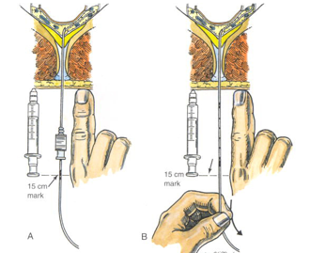
Measurement Method: Tread the catheter until the 15cm mark is in the window. Measure the distance from the skin to the window (using a syringe or your finger). Remove the needle from the back without removing the catheter. Measure the distance from the skin to the 15cm mark, it should be the same.
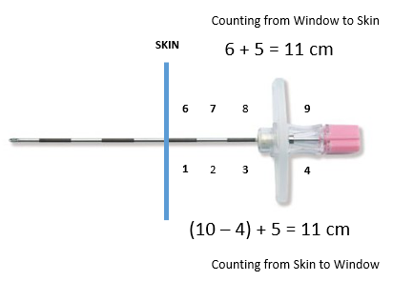
Counting from Skin: Tread the catheter into the epidural space and stop when the 20 cm mark begins to enter the needle. Count the number of centimeters from the skin (starting with #1) to the window in the needle and subtract that number from 10. This is the depth from skin to the epidural space; add 5 to this number. You want this cm dot at the skin when you pull back the catheter (after you remove the needle). This will leave 5 cm in the epidural space.

Counting from window: Tread the catheter into the epidural space and stop when the 20 cm mark begins to enter the needle. With needle in epidural space, count backward (starting with #9) the number of centimeters from the window to the skin. Whatever number you come up with, add 5 to it. You want this cm dot at the skin when you pull back the catheter (after you remove the needle). This will leave 5 cm in the epidural space.

- Read about different local medications know duration etc.
- When you are doing a C-section make, sure you always set up for a general as well. (ETtube, suction, check machine, blade)
- Practice with our kit if you have not done any; maybe watch a YouTube video?
  - https://youtu.be/0HQOlgUKhPI
  - https://youtu.be/VQ_kp-HM29E

Spinals:
- We dose with 0.75% bupivacaine height base
  - If……… 4’11’’………. 1.2ml
  - If……… 5’3” maybe… 1.4ml
  - If……… 5’9” ………..1.8ml
- We also put fentanyl and duromorph in the spinal:
  - Most use 10-20 mcg of fentanyl and 0.1 - 0.2 mcg of duromorph.
- Most of the CRNAs pretreat BP as soon as they lay down the patient supine, depending upon the patient vitals.
  - Neosynephrine or ephedrine is used to treat decreased in BP, depending on heart rate.
- Pitocin is administered after the baby is out and the cord clamped. Some providers use a premade bag 30units/500ml. others use 20-30 in 1000ml. depending on heart rate.

Students should understand:
- What layers they are going through?
  - Same layers as an epidural, but going further through the dura and arachnoid layers
- Why we are worried about pts blood pressure and effects of low BP on baby?
  - Placental circulation has limited autoregulation; thus, maintenance of uteroplacental perfusion largely depends on maintenance of maternal blood pressure. Decrease in a patient’s blood pressure will decrease uterine blood flow and baby’s perfusion. Decreases in mom’s BP will result in fetal compromise and decrease in fetal heart tones. Like to keep mom’s systolic BP above 100 mmHg.
- Doses of ephedrine and neosynephrine?
  - Traditionally, ephedrine 5 to 10 mg has been administered; however, studies in women undergoing spinal anesthesia for elective cesarean delivery have shown that phenylephrine 40 to 100 mcg is equally efficacious in restoring blood pressure.
  - Because there is no evidence that the choice of vasopressor influences maternal or neonatal outcome, the use of either drug is acceptable. The FHR should be monitored continuously, and treatment should be more aggressive if non-reassuring FHR patterns are noted or if the mother is symptomatic
  - Ephedrine crosses the placenta and may increase both FHR and FHR variability.
- Why we left tilt that patient after epidural and especially after a spinal is inserted?
  - The full lateral position minimizes aortocaval compression but does not allow performance of cesarean delivery. The 15 degrees of left lateral tilt (left uterine displacement) significantly reduces the adverse hemodynamic consequences of the supine position, although both the aorta and inferior vena cava may remain partially compressed. However, most anesthesia providers underestimate the degree of lateral tilt.
  - Hypotension is often defined as a 20% to 30% decrease in systolic blood pressure (compared with baseline) or a systolic blood pressure less than 100 mm Hg.
- What level we need the spinal to be at for C-section – which level is nipple, xyphoid, umbilicus?
T4 – Nipple line
T6 – Xyphoid process
T10 – Navel
T12 – Anterior Superior Iliac spine (Pubis)
- Sympathetic Block will be 2 dermatomes higher than the Sensory block, while the Motor block will 2 dermatomes lower than the Sensory block
- Side effects of Pitocin – running to fast what could happen/
  - Bolus may cause hypotension and possible cardiovascular collapse; give slowly
- Which patients cannot have methergine? Which patients cannot have hemabate?
  - Methylergonovine 0.2 mg IM; contraindicated in pts with HTN, seizures, CVA, retinal detachment, and cardiac arrest. Can be given IV slowly only during life threatening hemorrhage. May cause HTN.
  - Hemabate 250 mcg IM; used with caution in pts with history of asthma, hypo- or hypertension, anemia, diabetes, or epilepsy. Can cause N/V, diarrhea, fever, tachycardia, tachypnea, HTN, and bronchoconstriction.
Practice with our kit
Sterile technique: (Important)
- Anything below the waste is not sterile
- Prep from inside to outside and do not go back over insertion site after you have prepped outside
- Do not throw objects on floor and if you do such (as drape tape) please PICK IT UP, not one of our CRNA throws things on the floor

- Keep objects in the middle of the sterile field
- Try to stay vigilant about not contaminating yourself and if a CRNA asks you to change your gloves, do not question them
Generals Cases
You should know doses and about:
Zemuron Propofol Robinul Neostigmine
Zofran Decadron Lidocaine Fentanyl

Pediatric Cases
We do a lot of pediatric at this facility. Before a pediatric case, you are EXPECTED to:
- Have drugs calculated
- Know the size of endotracheal tube and tube depth,
- Calculate fluids for the patient. You should have fluids calculated before you roll, if you have not you need to speak up.

