Women’s and Children’s Hospital
4600 Ambassador Caffery Parkway
Lafayette, La 70508
(337) 521-9100

Clinical Coordinator: Kathryn Collins, CRNA
Phone (337)298-4422
Email: kcollins@essentialanesthesia.com

Onboarding Dept. FMOLHS: Josie Musso
Phone: (225)765-5952
Email: academics@fmolhs.org

- 2023 Attestation Form Template sign & send to academics@fmolhs.org as soon as all of the requirements are met. Attestation form will be completed by emailing LSUHSC Student Affairs nsclinicalcompliance3@lsuhsc.edu
- 2023 Confidentiality Agreement sign & send to academics@fmolhs.org ASAP as it could take up to 2 weeks to process. Confidentiality Agreement Forms are good for 1 year from the date signed. If it expires during their rotation, the student must submit a new one in order to cover their rotation.
- 2023 Contract Annual Education sign and send to academics@fmolhs.org
- 2023 Affiliation Agreement Forms (3 in all) sign & send to academics@fmolhs.org
- 2023 Supervising Practitioner’s Form forward to Kat Collins and academics@fmolhs.org

Orientation to Clinical Site
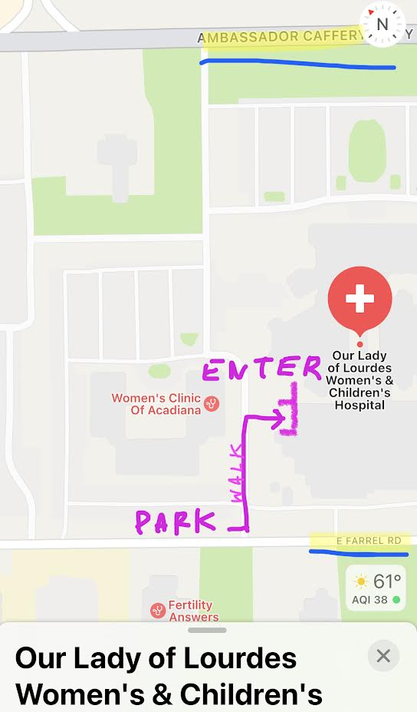
- ENTRY: Park in the back of building A, Women’s Clinic, along Farrel Rd. (See map) Enter side door as pictured (code 2246) Elevators to left. Go to the 2nd floor. Walk out and turn right to a closed set of doors. Code is also 2246. Or ring the doorbell and wait for someone to open.
- Once coming through doors, turn right and walk past the desk, our CRNA office is located to the right of pt rooms across from the Women’s Locker Room. Meet us in here so we can welcome you!
- Women’s locker room: Across CRNA office. The code is 787. Your bag can be placed in any open locker in the locker room. Feel free to bring a lock if you would like.
- Men’s locker room: located to the left when leaving the CRNA office through the door to the left.
- Arrival: 0610.
- You are allowed to wear your own scrubs.
- Required: Your LSU school badge must be worn at ALL TIMES.
- Anesthesia Door codes:
OR/ Side Entry Door Keypad: 2246
OB/MRI Anesthesia carts: 5243
Epidural carts: 243
Epidural Pump Code: 824
OR/OB/PACU workroom: 7010
2nd Floor Dr’s Lounge: 007 – may get snacks, but don’t linger
- If you are unable to attend clinical for any reason, you must notify your clinical coordinator
- The hospital cafeteria is located on the first floor for those who choose this option – please say you are with anesthesia (BE VERY NICE to cafeteria staff as this FREE lunch can be taken away!)

Expectations of SRNA
- We have 5 ORs, 1 Cysto room, 2 ORs on L&D, and 1 peds sedation room.
- Case Mix: neonatal surgeries, peds – genitourinary, bowel, orthopedic, neurology, and ENT; adult – urological, OB-GYN, mastectomies, and general cases.
- The SRNA will be allowed to perform spinals, epidurals, & QL blocks after being proctored by a CRNA or MD.
- SRNAs are also expected to conduct post-op rounds BEFORE leaving for the day – these are for patients who had a C/S the day before, or received IT narcotics, nerve blocks, or PCA.
- Please introduce yourself to patients and staff as a registered nurse training to be a nurse anesthetist. DO NOT use the word “resident” under any circumstances. It is fair and right to notify patients you are in training and dishonest to simply say, “I’m with anesthesia”. Yes, you WILL lose out on some opportunities because patient’s are nervous, but we have PLENTY of more opportunities for you. This is a big issue in our hospital and you MUST be respectful of this.

Patient Assignments
- Between the two LSU SRNAs, one will be OB and one should choose an OR. The first two weeks will serve as your orientation, you will spend one week doing OB only and one week in OR only. After this, you alternate everyday (i.e. one SRNA will be OB M/W, and OR T/R).
- OR SRNA: This is an OB/GYN rotation, so first pick is always C/Sections. Then GYN cases. You may work on your peds cases here as well. Consider which case types you need. C/S roll EARLY
- OB SRNA: Please check machines and setup in OB ORs before anything else. If the OB board is busy, wait in CRNA office for OB CRNA to arrive. If not busy, you may pick an OR. If there’s a second C/S room, please pick that. Ensure that you check in with the OB CRNA so they know where to find you or you may miss opportunities if we have to figure out where you are.
      - If you are the OB SRNA for the day, please do the post-op rounds
- This is the Peds rotation for TCU so they will get priority on Peds.
- Pre-ops are performed by the anesthesiologist, but the SRNA is expected to interview his/her patient
- DO NOT START ANY REGIONAL OR GENERAL WITHOUT A CRNA OR MD PRESENT UNDER ANY CIRCUMSTANCE.
- Patients will occasionally request a particular CRNA or Anesthesiologist. This is a patient’s right, and the SRNA should respectfully comply.

Daily Clinical Routines
- 0615-1500 – Sx start times:0700, C/S start 0645
- Set up room, check machine, and prepare all needed medications
- Review the chart – labs and history
- Head to pre-OP and interview your patient.
- Ensure all consents are signed
- Prior to rolling to the OR, the surgery team does a timeout in pre-op. CRNA must be present for this and give OK to roll.
- Our pre-op nurses generally give Versed and will give you the pre-op antibiotic.
- Absolutely NO medications are to be administered before checking in with CRNA

Case Requirements:
- Know drug dosages for peds and adult patients and Mechanisms of Action for all drugs used but specifically Propofol, Lidocaine, Rocuronium, Succinylcholine, Atropine and Fentanyl.
- Calculate fluid management and ABL for all cases prior to starting, especially peds.
- Know formula for ETT size and depth for peds. ETT size= (age/4)+3.5 Depth= ETT size x 3
- Review pediatrics, OB, and regional lectures.
- Be attentive to sterile technique when performing regional anesthetics. If someone tells you that you are contaminated, do not argue. Just start over.

